

To Espoo Point of Contact Russia, Estonia, Latvia, Lithuania and Finland
The following countries are to be notified:
Germany, Poland, Russia, Estonia, Latvia, Lithuania, Finland, Sweden and Norway

Notification of environmental impact assessment of the Eastern Ring Road

Legal authority
The Espoo Convention¹ on Environmental Impact Assessment in a Transboundary Context, which has been incorporated into the Environmental Impact Assessment Directive² and the Strategic Environmental Assessment Directive³, along with the Danish Public Roads Act⁴, requires the parties to notify and enter into consultations with affected countries and carry out transboundary environmental impact assessments.

Denmark hereby notifies Germany, Poland, Russia, Estonia, Latvia, Lithuania, Finland, Sweden and Norway of consultations of public authorities on the scoping of the environmental impact assessment of transboundary environmental impacts, in response to the requirement to conduct an environmental impact assessment process for the Eastern Ring Road project. Notification is given pursuant to Article 7 of the EIA Directive.

Description of the Eastern Ring Road project
On 28 June 2021, a political agreement was reached between the Danish government and a number of parties on the “Infrastructure Plan 2035”. Based on this agreement, the Ministry of Transport published the political terms of reference for the environmental impact assessment of the Eastern Ring Road in April 2023. The terms of reference state that the Eastern Ring Road is to be planned around an immersed tunnel along the east coast of Amager.

The Eastern Ring Road will connect the Helsingør motorway in the north with the Øresund motorway in the south, with four possible access points at Nordhavn, Lynetteholm, Prøvestenen and Kastrup; see also map in figure 1.
Landscape and Forestry case-no 2023 - 106578
Ref. mveje
Date 15. March 2024

1 Convention of 25 February 1991 on Transboundary Environmental Impact Assessment
2 Directive 2011/92/EU of 13 December 2011 on the assessment of the effects of certain public and private projects on the environment
3 Directive 2014/52/EU of the European Parliament and of the Council of 16 April 2014 amending Directive 2011/92/EU on the assessment of the effects of certain public and private projects on the environment, and Directive 2001/42/EC of the European Parliament and of the Council of 27 June 2001 on the assessment of the effects of certain plans and programmes on the environment
4 Consolidated Act no 421 of 25 April 2023 on public roads etc.

Danish Environmental Protection Agency • Tolderlundsvej 5 • DK-5000 Odense C
Tel. +45 72 54 40 00 • CVR 25798376 • EAN 5798000860810 - mst@mst.dk - www.mst.dk

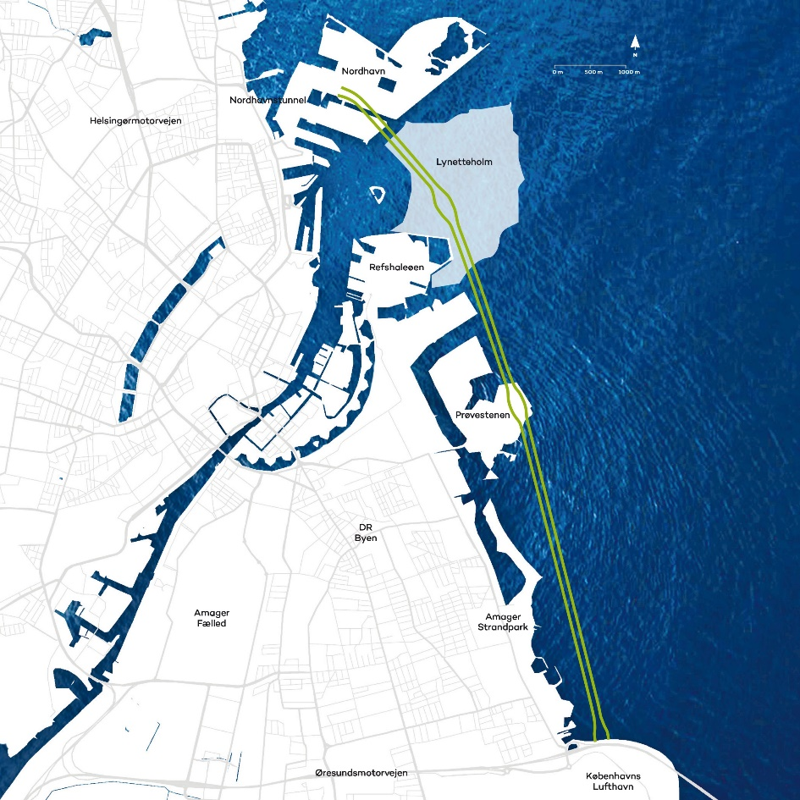
Figure 1 The Eastern Ring Road will run along the east coast of Amager, connecting the Helsingør motorway in the north with the Øresund motorway in the south.

The immersed tunnel will be made up of several individual tunnel elements, to be produced at the tunnel element factory and then towed by sea to the project site outside Copenhagen. The tunnel elements will be produced at the Fehmarnbelt Fixed Link tunnel element factory in Rødbyhavn on Lolland.

The elements will placed end to end on the seabed in a pre-dredged tunnel trench. Once they are in place, the tunnel elements will be covered with a protective layer and the seabed restored on top of the trench.

In the continued work on the design and environmental impact assessment of the Eastern Ring Road, a wide range of technical and environmental matters need to be investigated in more detail. For example, the final design of the tunnel, the technical solutions for the four different access points, the capacity of the road and the connections to the surrounding road network have to be determined. As part of the project, raw materials for the construction of the tunnel are also expected to be extracted at sea in an area still to be confirmed. Finally, it remains to be clarified whether relocating wastewater pipes, for example, will result in any new discharge points into the sea.
For more information about the Eastern Ring Road, including the continued process, please visit the project website: Eastern Ring Road . The website is updated regularly.

Possible transboundary impacts on the environment
Based on the project description (see preceding text), the following issues have been initially identified as relevant to investigate and assess further in relation to potential transboundary impacts during the construction and operational phases of the project: changes in hydrography and sediment dispersion, impacts on marine flora and fauna, water quality, underwater noise, CO2 emissions, shipping and traffic conditions on land. This list is not necessarily exhaustive.

Invitation to participate in the consultation process
The task of preparing an environmental impact assessment of the Eastern Ring Road project is being undertaken by the state-owned company Sund & Bælt, which has been delegated the task by order of the Minister of Transport. According to the Executive Order, the Danish Transport Authority will handle the necessary regulatory matters.

The environmental impact assessment of the Eastern Ring Road is covered by the process described in Chapter 2a of the Danish Public Roads Act on environmental impact assessment of state road projects. This means that Sund & Bælt may choose to obtain a scoping opinion from the Danish Transport Authority before drawing up the environmental impact report. Among other things, the Authority will base its opinion on the results of a consultation with relevant Danish authorities 20. March to 19. april. In parallel with the Danish authorities, possible affected states will be consulted in accordance with the rules of the Espoo Convention.

Following the consultation and the scoping opinion from the Danish Transport Authority, the environmental impact assessment of the Eastern Ring Road is expected to be carried out up to and including 2025. The environmental impact report will then be sent out for public consultation in Denmark, and the Espoo report will be sent to potentially affected states, probably for 8 weeks.
The documentation will be translated into the relevant languages; however, maps will only be available in Danish and English. Based on the environmental impact assessment and consultation, a political decision will be made on a possible Construction Act for the Eastern Ring Road.

If you wish to participate in the environmental impact assessment process and have any requests or comments on the potential transboundary environmental impacts to be investigated in the environmental impact report, please send your request for participation or comments no later than 19.04.2024 to Espoo@mst.dk, quoting reference number: 2023 - 106578

Kind regards,

Martin Vestergård Jensen
AC-medarbejder | Landskab & Skov | Miljøvurdering & Espoo
+45 | +45 29 61 70 53 | mveje@mst.dk

