Riga, 30 June 2026
Valsts vides dienestam
Rūpniecības iela 23,
Riga, LV-1045

Application for the construction of the “Smikši” wind farm and the infrastructure associated with it in Kalēti and Gramzda parishes, Dienvidkurzeme municipality, amending the application of 29 September 2025 for the construction of the “Smikši” wind power plant park in Dienvidkurzeme municipality

In accordance with Cabinet of Ministers Regulation No. 18 of 13 January 2015 “Procedure for assessing the environmental impact of a proposed activity and accepting the proposed activity”

The information on environmental impact has been prepared taking into account the recommendations compiled in the document “Guidelines for carrying out an initial environmental impact assessment for evaluating the environmental impacts caused by the construction of wind power plants” (hereinafter – the Guidelines) for the assessment of those impacts that have been recognised as significant, or as potentially significant under certain circumstances, or as disruptive in the context of the construction and operation of wind farms. Pursuant to Section 4 of the “Law on the Facilitated Construction Procedure for Energy Supply Structures Necessary for Promoting Energy Security and Independence”, the application of the “Smikši” wind power plant park for the initial assessment has been prepared taking into account the following requirements: The construction of wind power plants is permitted outside cities and villages, in areas designated in the local government’s spatial plan as industrial development areas, technical development areas, agricultural areas, and on forest land, provided that the distance from residential and public buildings to the nearest planned wind power plant and to the boundary of the wind farm is at least 800 metres.” Pursuant to Section 5 of the aforementioned law, the construction of wind power plants is planned outside specially protected nature territories, including outside the 2 km buffer zone established around Natura 2000 sites and micro-reserves created for bird protection; the construction of wind power plants is planned outside specially protected biotopes and species habitats, and outside the protection zones of the Baltic Sea coast, surface water bodies and cultural monuments.
The impact assessment reflected in the application and its annexes has been prepared by SIA “Estonian, Latvian & Lithuanian Environment” and other engaged specialists (experts) of the relevant fields.
Name of the initiator: SIA “EWE Neue Energien 5”
Registration number: 40203572652
Registered address: Marijas iela 2A, Riga, LV-1050
Telephone number: +371 29155187
E-mail address: info-lv@eurowindenergy.com

Name of the proposed activity (facility):
Construction of the “Smikši” wind farm in Dienvidkurzeme municipality, Kalēti and Gramzda parishes.

Information on the possible locations of the proposed activity and their characterisation, taking into account the environmental condition and sensitivity of the location and of the territory potentially affected by it:
The construction of the “Smikši” wind farm is planned in Dienvidkurzeme municipality, Kalēti and Gramzda parishes. The construction of the power transmission cable lines is also planned in Virga and Bārta parishes, where the planned wind farm would be connected to a substation. Together with the substation, the installation of battery energy storage systems (hereinafter – BESS) is also planned. In accordance with the conditions of Section 21 of the Energy Law, the power transmission cable lines are, as far as possible, located within the right-of-way strips of roads held by the state, local governments and commercial operators. The wind turbine generators (hereinafter – WTG) and the infrastructure associated with them are planned to be built on agricultural and forest land.
During the planning process, 4 alternative locations for the construction of the substation and BESS have been identified, namely substation and BESS “A”, “B”, “C” and “D” (see Figures 1 and 2). During the planning process, 4 alternative cable line solutions have been identified: alternatives 1, 2, 3 and 4. Substation “A”, at which the possibilities of constructing the BESS are also assessed, is the user part of the substation, which will be connected to all WTGs using medium-voltage cable lines. User substation “A” will be connected to the grid operator’s substation at construction site “B”, “C” or “D” using a high-voltage cable line. Alternative 1 connects the user part of the substation with substation construction sites “B” and “C” along the northern side of the farm. Alternative 2 connects the user part of the substation with substation construction site “D” along the northern side of the farm. Alternative 3 connects the user part of the substation with substation construction sites “B” and “C” along the southern side of the farm, whereas alternative 4 connects the user part of the substation with substation construction site “D” along the southern side of the farm.
The construction of the wind farm and the infrastructure associated with it will affect 24 land units belonging to natural and legal persons, and 15 land units belonging to the local government and the state. Detailed information on the land units in which the construction of WTGs and associated infrastructure is planned is compiled in Annex 1 to the application, while the layout of the wind farm and associated infrastructure is shown in Figures 1 and 2. The WTGs and the infrastructure associated with them will be built only on those land units whose holders have reached an agreement on the siting of WTGs and the construction of cable routes and roads.
The nearest populated place to the planned WTGs is Gramzda, Gramzda parish, located 1.1 km from the nearest WTG construction site. The village of Ozoli, Kalēti parish, is located 1.3 km from the nearest planned WTG; Kalēti, Kalēti parish, is located 3.1 km away. Mazgramzda, Priekule parish, is located 5.5 km away, whereas Dāma, Gramzda parish, is located 5.7 km away. The nearest town, Priekule, is located approximately 8.7 km away. Within 2 km of the planned WTGs there are 138 residential and public buildings registered in the cadastral information system – one registered structure was not found on site. Within 3 km of the WTGs the number of buildings reaches 199. Information on the residential development areas located closer to the proposed activity is compiled in Table 1. Three residential buildings registered in the cadastral information system that are located less than 800 m from the planned WTGs are currently uninhabited and it is planned to demolish them completely and remove them from the register before the building permit is obtained.
Several state and local cultural monuments and their protection zones are located near the territory of the proposed activity of the “Smikši” wind farm (see Figure 4). The following cultural monuments are located within 2 km:
- Cultural monument of national significance Ozoli ancient burial ground (protection no. 1348);
- Cultural monument of national significance Lanki ancient burial ground (protection no. 1347);
- Cultural monument of local significance Pilskalns (hill fort) (protection no. 1334).
Likewise, the protection zones of the following cultural monuments are located within 2 km:
- Cultural monument of national significance Sauši settlement (protection no. 1351);
- Cultural monument of national significance Upīši ancient burial ground (protection no. 1339);
- Cultural monument of regional significance Rači settlement (protection no. 1350).

The WTG construction sites do not affect the protection belts (protection zones) of state-protected cultural monuments. The cable route line crosses the protection belt of the cultural monument of local significance Pilskalns (protection no. 1334), as well as the protection belts of the cultural monument of national significance “Purmsāti (Upes) hill fort” (protection no. 1446) and of the cultural monument of regional significance Kalviņi medieval cemetery (Swedish Graves) (protection no. 1443).
The territory of the proposed activity of the “Smikši” wind farm is not located within a specially protected nature territory (hereinafter: SPNT); no micro-reserves established for the protection of particular species have been created within it. The nearest SPNT – the natural monument Kalēti Park – is located 2 km from the nearest WTG. Within 5 km of the WTGs there are 8 micro-reserves established for the protection of specially protected bird species. The nearest micro-reserve (no. 2765), established for the protection of the lesser spotted eagle, is located approximately 2.8 km from WTG 8. More extensive information on natural values in the vicinity of the construction sites is compiled in Section 10 of the application and shown in Figure 7.

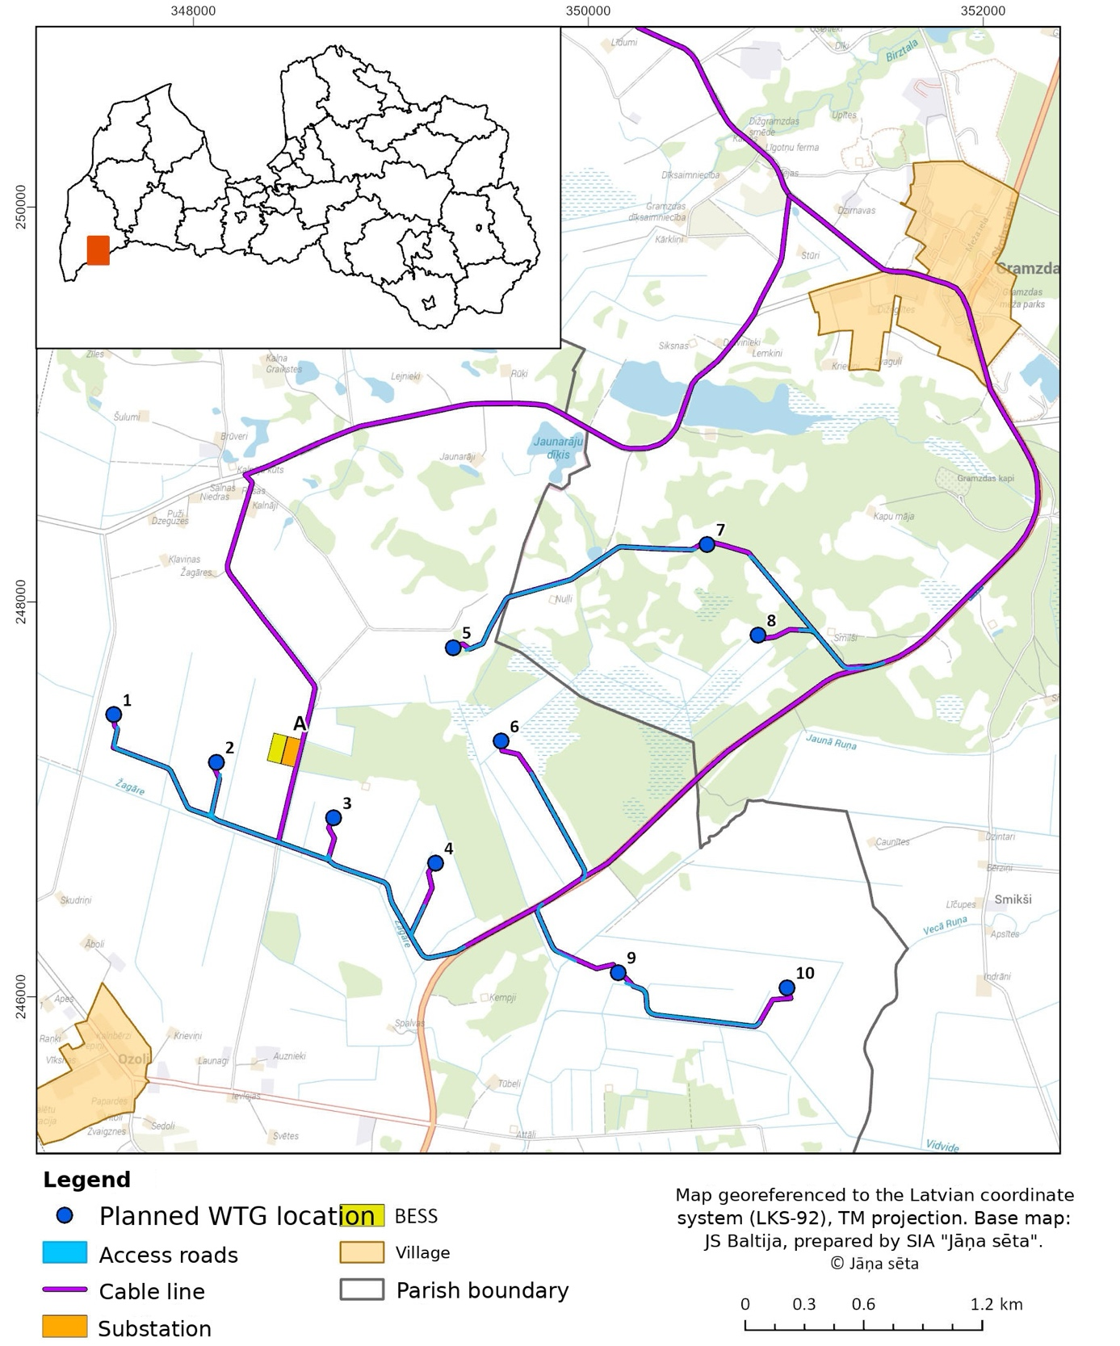

Figure 1. Layout of the WTGs and associated infrastructure of the proposed activity “Smikši”

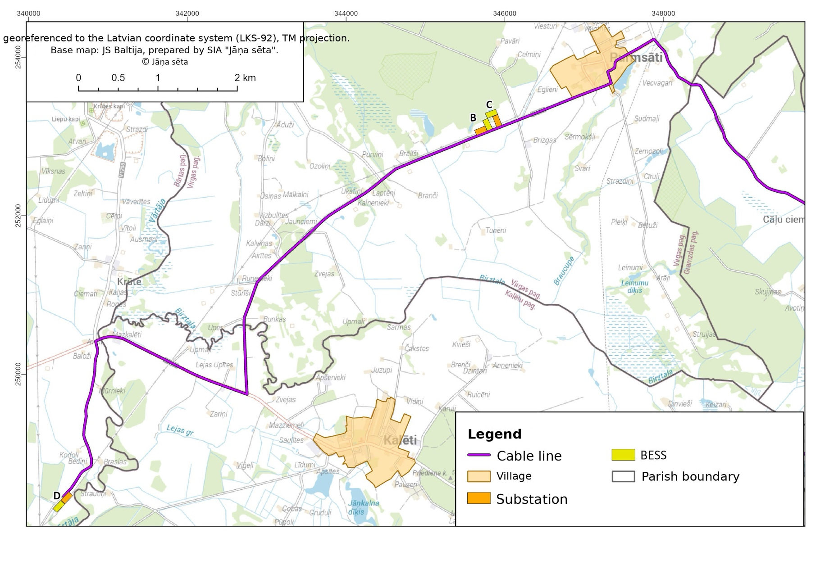
Figure 2. Layout of the planned BESS alternatives B, C and D
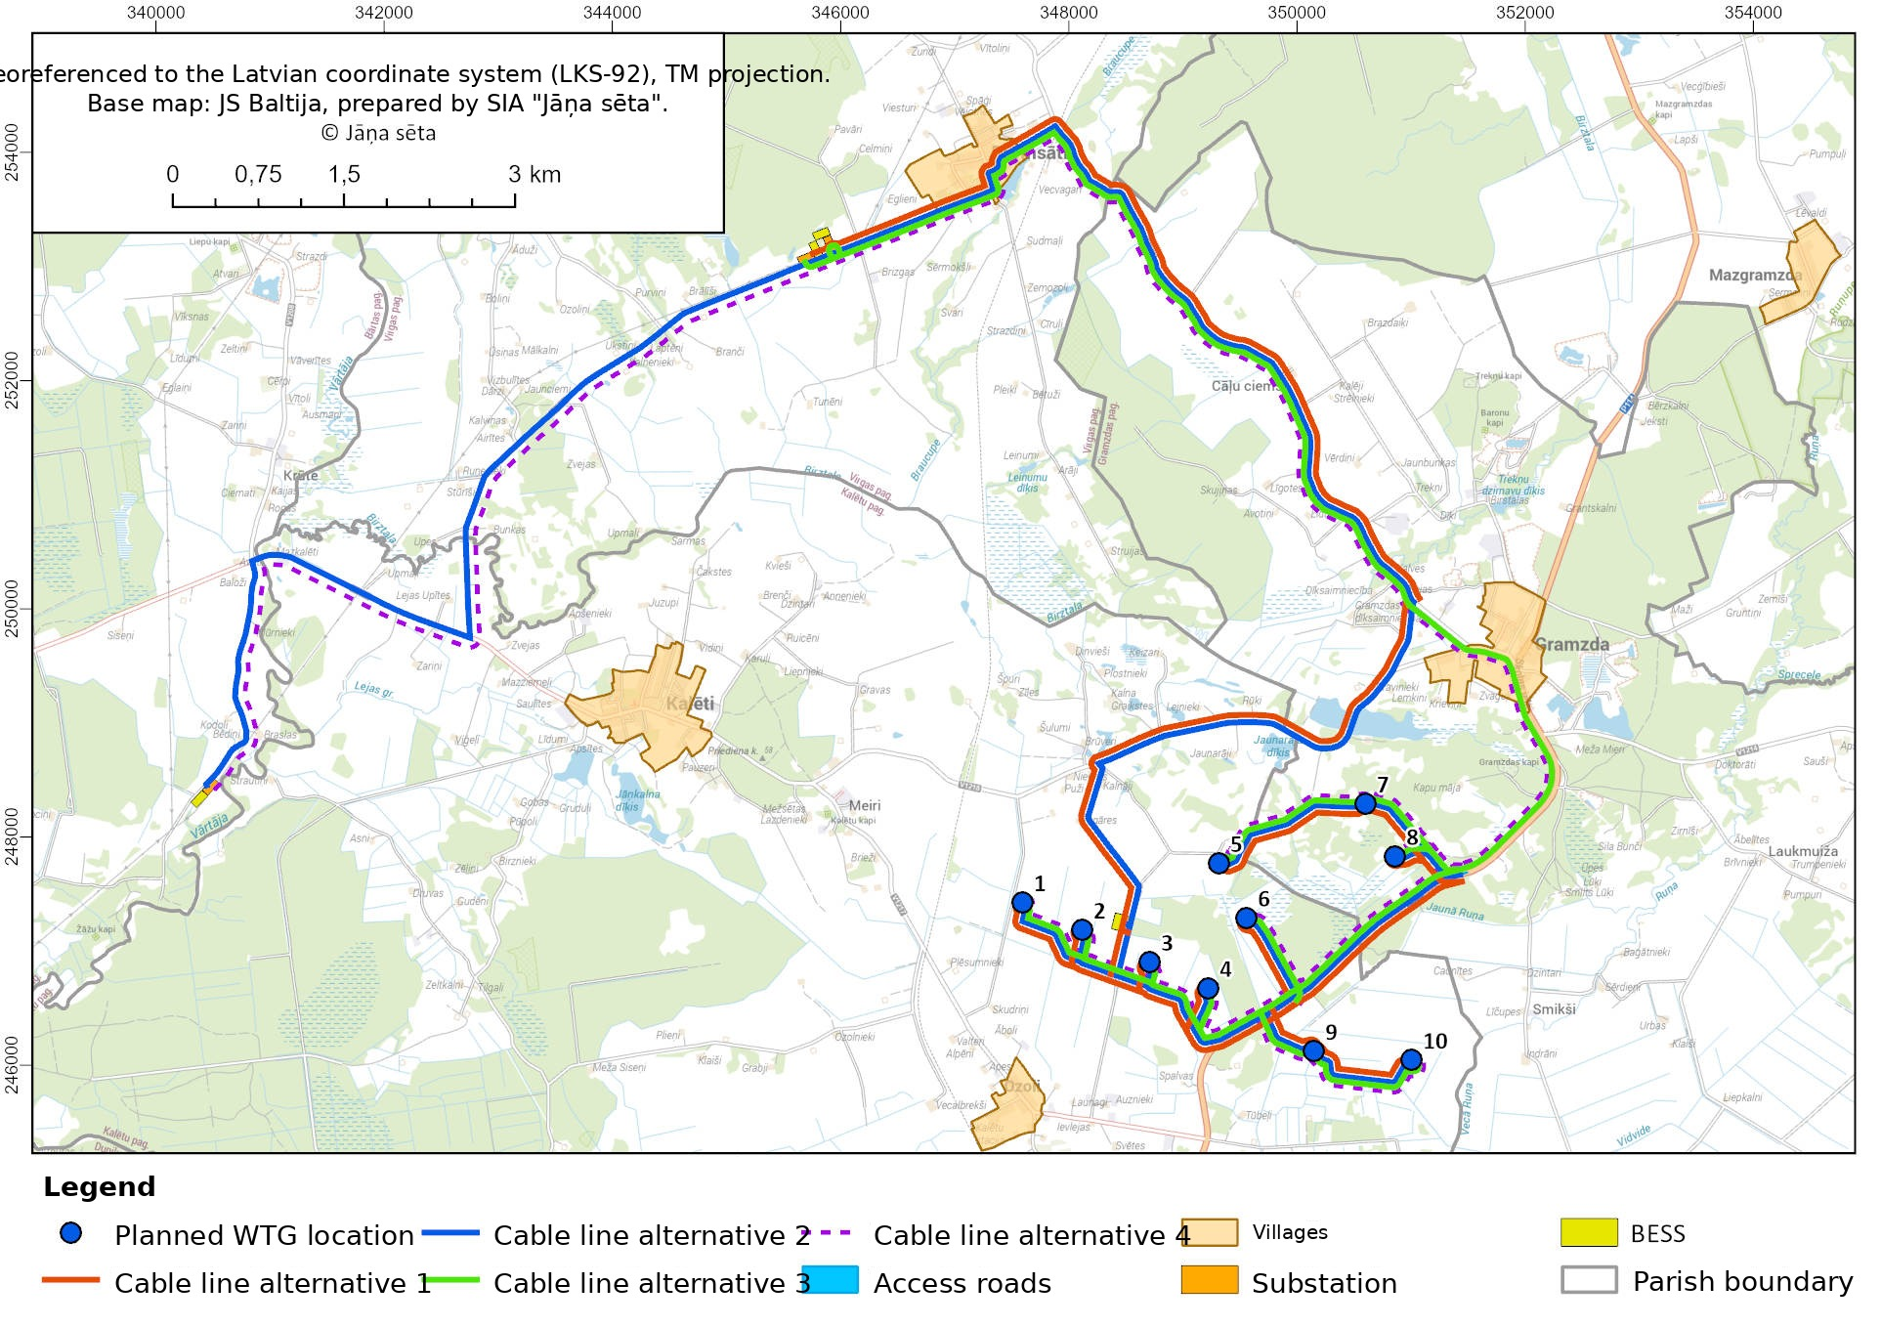
Figure 3. Layout of cable line alternatives 1, 2, 3 and 4

- Table. Nearest residential buildings (within 2 km)
No. | Cadastral designation of the residential building | Name of the residential building | No. of the nearest WTG | Distance to the nearest WTG, m
 | 64580010015001 | Smilši | 2 | 368
 | 64580010231001 | Nuļļi | 1 | 564
 | 64640040168001 | Ķempji | 4 | 661
 | 64640030015001 | Kļaviņas | 3 | 818
 | 64640040064001 | - | 3 | 826
 | 64640040139001 | - | 4 | 827
 | 64640040116001 | - | 9 | 830
 | 64580010003001 | Cemetery house | 2 | 832
 | 64640040026001 | Ūdiķi | 10 | 851
 | 64580010232001 | Caunītes | 10 | 856
 | 64640030014001 | Žagāres | 3 | 872
 | 64640030013001 | Jaunarāji | 1 | 967
 | 64640040148001 | - | 3 | 972
 | 64640040200001 | Paipas | 4 | 983
 | 64580010020001 | Lemkini | 5 | 991
 | 64580010263001 | Indrāni | 10 | 994
 | 64640030007001 | - | 3 | 995
 | 64580010194001 | Siksnas | 5 | 1009
 | 64580010192001 | Dravinieki | 5 | 1021
 | 64580010395001 | Līčupes | 10 | 1044
 | 64640030010001 | - | 3 | 1054
 | 64580010259001 | - | 10 | 1060
 | 64580010188001 | Krieviņi | 5 | 1093
 | 64640040123001 | Ķera Ostnieki | 4 | 1104
 | 64640040068001 | Āboli | 6 | 1131
 | 64580010253001 | Bērziņi | 10 | 1171
 | 64640030008001 | - | 3 | 1179
 | 64640030003001 | Kalnāji | 1 | 1244
 | 64580010251001 | Dzintari | 10 | 1254
 | 64640020012001 | Liekņi | 3 | 1256
 | 64640030012001 | Salnas | 3 | 1266
 | 64640040111001 | Mazauznieki | 7 | 1298
 | 64640030005001 | Rasas | 3 | 1300
 | 64640030019001 | Rūķi | 5 | 1316
 | 64640020005001 | Brieži | 3 | 1326
 | 64640040060001 | Valteri | 3 | 1343
 | 64640040006001 | Alpēni | 3 | 1347
 | 64580010063001 | Zvaguļi | 5 | 1363
 | 64640040082001 | Krieviņi | 7 | 1365
 | 64640030018001 | Lejnieki | 1 | 1380
 | 64640020069001 | Līgotņi | 3 | 1403
 | 64640040109001 | Launagi | 7 | 1404
 | 64580010136001 | Uzvaras iela 23 | 5 | 1417
 | 64640040058001 | - | 6 | 1447
 | 64640040080001 | Priednieki | 6 | 1448
 | 64640020097001 | Apiņi | 3 | 1455
 | 64580010190001 | Dižeglītes | 5 | 1459
 | 64580010139001 | Uzvaras iela 19 | 5 | 1467
 | 64640040079001 | Zaķīši | 6 | 1471
 | 64640040036001 | - | 7 | 1493
 | 64640040077001 | Ceriņi | 6 | 1496
 | 64580010187001 | Ķirši | 5 | 1498
 | 64640040059001 | Apes | 6 | 1502
 | 64580010027001 | Smilts Lūķi | 2 | 1503
 | 64640040039001 | - | 6 | 1506
 | 64640030028001 | Brūveri | 3 | 1506
 | 64640030026001 | Šulumi | 3 | 1507
 | 64640040075001 | Lazdas | 6 | 1511
 | 64640040002001 | Lankas | 9 | 1519
 | 64580010184001 | Stūri | 5 | 1533
 | 64640040073001 | Vējkalni | 6 | 1535
 | 64580010055001 | Kārkliņi | 5 | 1541
 | 64640040055001 | Pepiņi | 6 | 1552
 | 64640020064001 | Pirtnieki | 3 | 1557
 | 64640040072001 | Strazdiņi | 6 | 1558
 | 64640040071001 | Austrumi | 6 | 1582
 | 64640040046001 | Smilgas | 6 | 1583
 | 64580010044001 | Morēnas | 5 | 1595
 | 64640040057001 | Raņķi | 6 | 1597
 | 64580010062001 | Nākotnes iela 11 | 5 | 1597
 | 64640040045001 | Ceļmalas | 6 | 1602
 | 64640040117001 | - | 9 | 1604
 | 64640040070001 | - | 6 | 1604
 | 64640020010001 | Venckas | 3 | 1619
 | 64580010219001 | Jasmīnu iela 3 | 5 | 1619
 | 64580010310001 | Uzvaras iela 15A | 5 | 1623
 | 64580010049001 | Jasmīnu iela 5 | 5 | 1630
 | 64640040047001 | Oškalni | 6 | 1646
 | 64640040054001 | - | 6 | 1668
 | 64580010056001 | Uzvaras iela 15 | 5 | 1674
 | 64580010028001 | Gramzda fish pond farm | 5 | 1678
 | 64640040048001 | Arāji | 6 | 1685
 | 64640020034001 | Meirāni | 3 | 1688
 | 64580010048001 | Uzvaras iela 13 | 5 | 1688
 | 64580010356001 | Liepnieki | 5 | 1697
 | 64580010034001 | Uzvaras iela 11 | 5 | 1700
 | 64580010047001 | Uzvaras iela 9 | 5 | 1711
 | 64640030029001 | Kalna Graikstes | 1 | 1718
 | 64580010064001 | DIMANTI | 5 | 1720
 | 64580010059001 | Nākotnes iela 1 | 5 | 1732
 | 64640040049001 | Pīlādži | 6 | 1734
 | 64580010311001 | Uzvaras iela 7 | 5 | 1750
 | 64640040043001 | - | 7 | 1754
 | 64640020063001 | Mazpirtnieki | 3 | 1755
 | 64580010100001 | Ziedoņi | 5 | 1763
 | 64580010275001 | - | 2 | 1781
 | 64580010217001 | Uzvaras iela 3 | 5 | 1781
 | 64580010248014 | Sērdieņi | 10 | 1790
 | 64580010248001 | Sērdieņi | 10 | 1794
 | 64580010039001 | Miera iela 2A | 5 | 1799
 | 64640040037001 | Sedoli | 7 | 1805
 | 64580010175001 | Dzirnavas | 5 | 1807
 | 64580010133001 | Uzvaras iela 2 | 5 | 1810
 | 64640040051001 | Puķīši | 6 | 1811
 | 64580010221001 | Ceriņi | 5 | 1815
 | 64640040050001 | Jaunozoli | 6 | 1827
 | 64580010230001 | Meža Mieri | 2 | 1827
 | 64640020082001 | - | 3 | 1836
 | 64640030023001 | Zīles | 3 | 1836
 | 64580010214001 | Miera iela 2 | 5 | 1848
 | 64580010028004 | Fish pond farm | 5 | 1864
 | 64640020009011 | Albrekši | 3 | 1876
 | 64640040044001 | Vītoli | 6 | 1879
 | 64640030002007 | Ķeizari | 1 | 1886
 | 64580010207001 | Skolas iela 6 | 5 | 1887
 | 64640020035001 | - | 3 | 1889
 | 64640040025001 | Zvaigznes | 7 | 1892
 | 64640030024001 | Špuri | 3 | 1902
 | 64580010167001 | Alejas | 5 | 1908
 | 64580010208001 | Gramzda Primary School | 5 | 1908
 | 64580010126001 | Grantiņi (structure not found on site) | 5 | 1918
 | 64580010215001 | Miera iela 4 | 5 | 1921
 | 64640020009001 | Albrekši | 3 | 1930
 | 64640030020001 | Plostnieki | 1 | 1948
 | 64580010026001 | Meža iela 3 | 5 | 1954
 | 64580010024001 | Skolas iela 1 | 5 | 1960
 | 64580010337001 | Miera iela 5 | 5 | 1960
 | 64640040022001 | - | 7 | 1968
 | 64640020037001 | Mazmeiri | 3 | 1997

According to the information included in the Contaminated Sites Management System of the State Environmental Service, there are no contaminated or potentially contaminated sites within the territory of the proposed activity of the “Smikši” wind farm. The nearest potentially contaminated site (no. 2360) is located ~12.6 km from the nearest WTG. Contamination by organic substances has been identified at the contaminated site (including pesticides, solvents, polychlorinated biphenyls, phenols, etc.).
According to the information available in the Subsoil Information System of VSIA “Latvian Environment, Geology and Meteorology Centre”, one field of forecast resources is located within the planned territory of the proposed activity of the wind farm (see Figure 4). The nearest field of forecast sand resources “Smilkši B575” (ID 348756) is located approximately 0.2 km from WTG No. 8. A field of forecast peat resources is located 0.9 km from WTG No. 7, whereas the nearest deposit “Gramzda – 1979” (B1841), where sand-gravel and sand extraction sites are registered, is located approximately 1.6 km from WTG No. 7.
The territory of the proposed activity is located in the catchment basin of the Venta River and mainly comprises drained rural land in which a dense network of drainage ditches has been created. The nearest watercourses of national significance are Vidvide (water body code 3428824:01) and Jaunā Ruņa (water body code 342882:01). Vidvide is located 218 m from WTG No. 9 and 254 m from WTG No. 10 respectively, whereas Jaunā Ruņa is located 200 m from WTG No. 9.

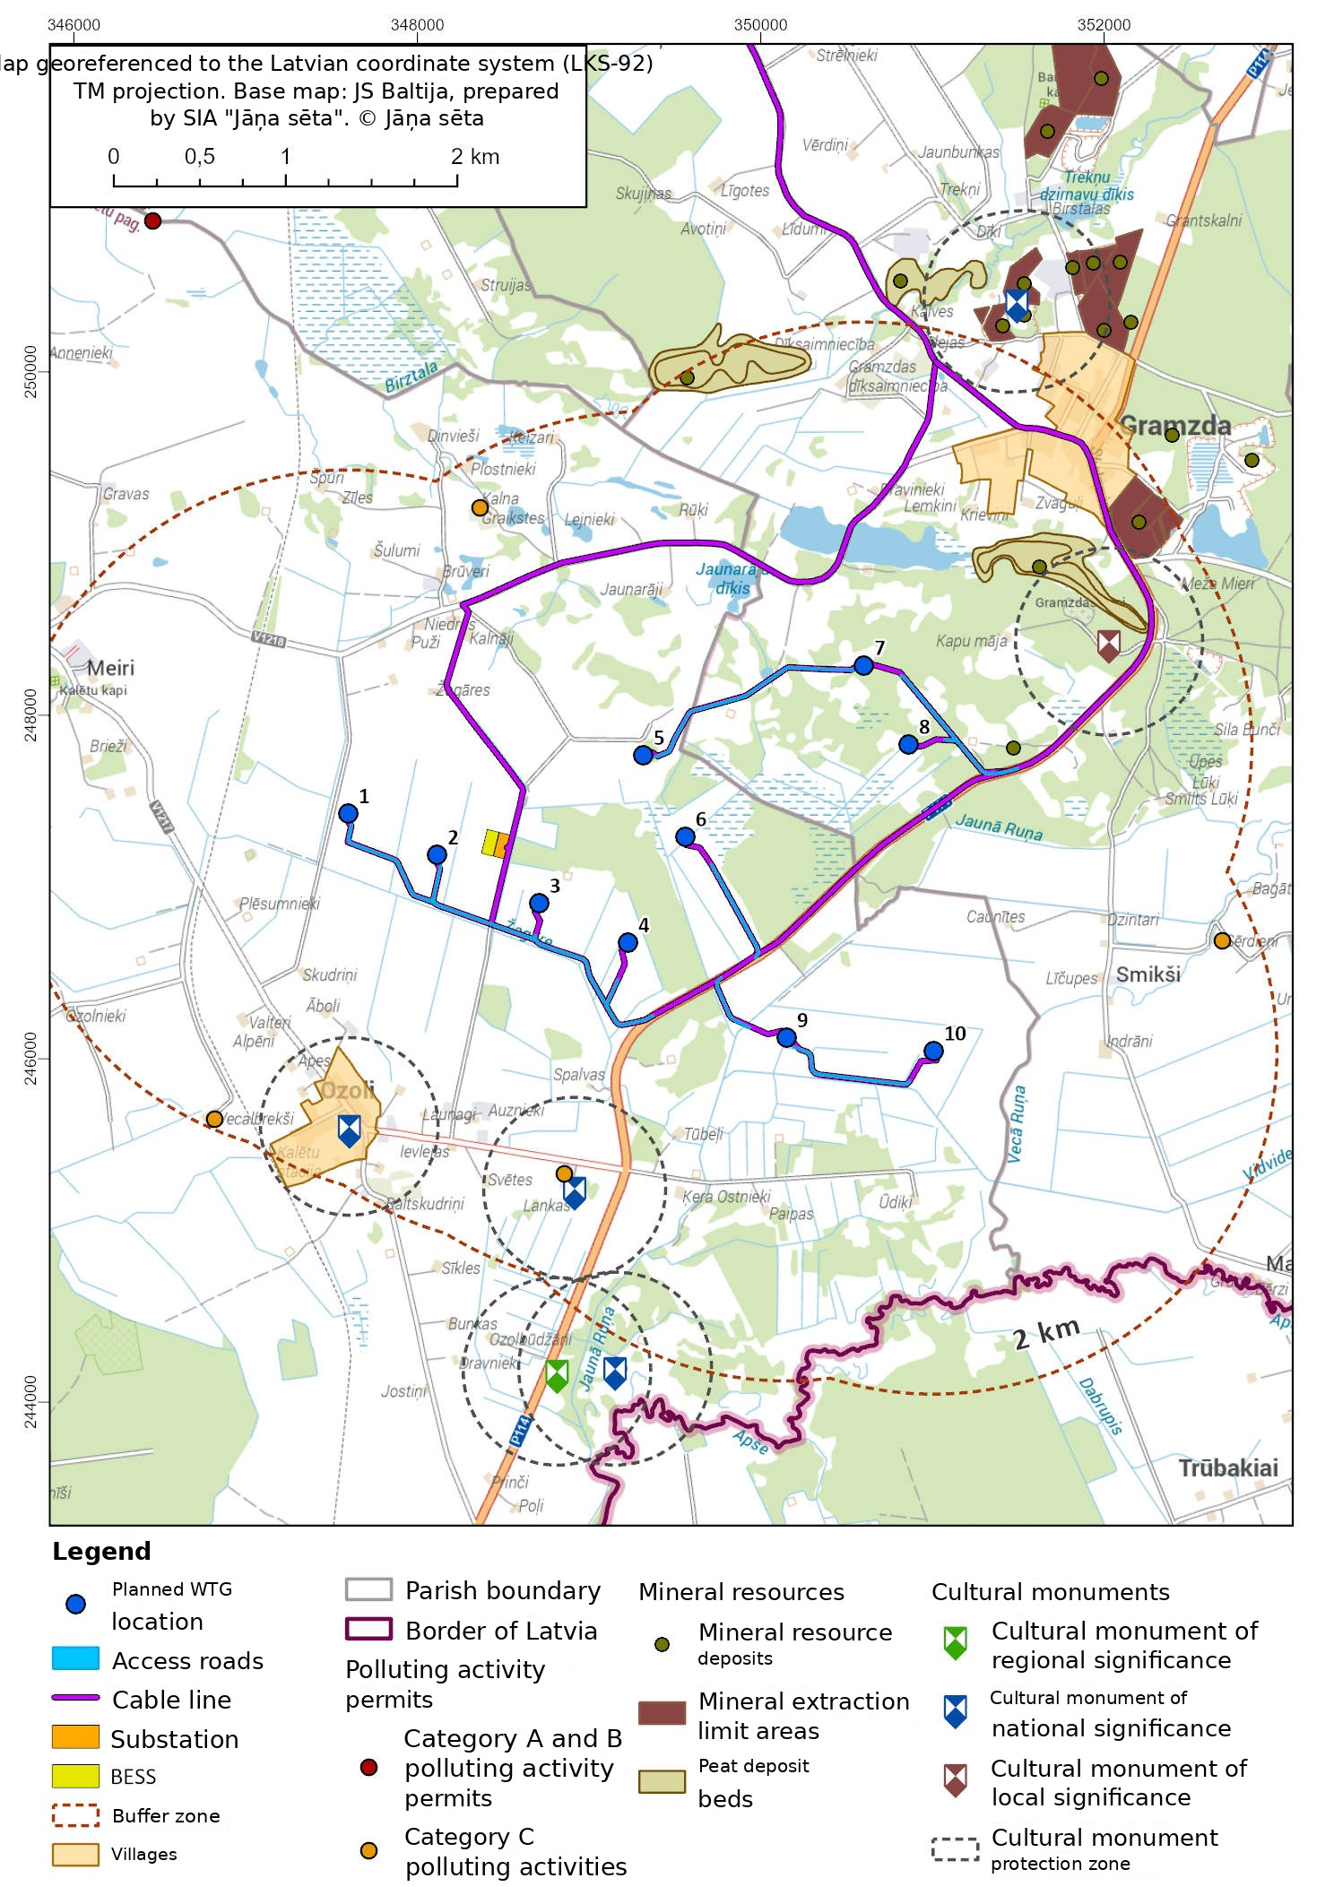

Figure 4. Objects located in the vicinity of the territory of the proposed activity

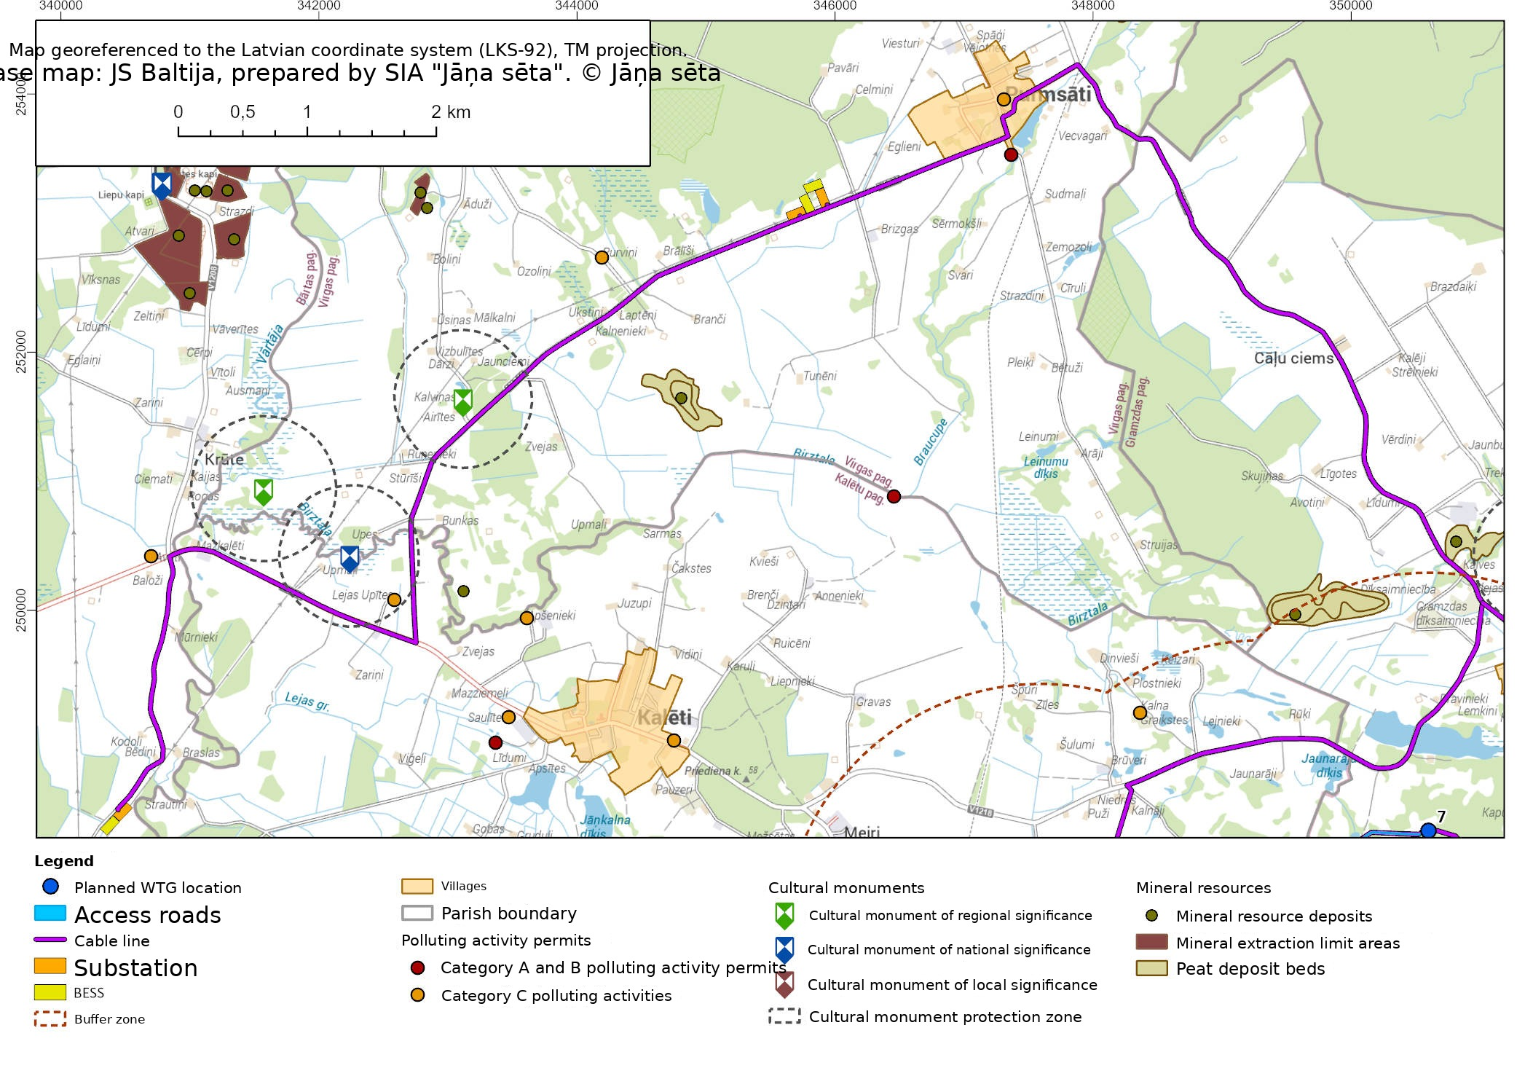
Figure 5. Objects located in the vicinity of the cable line

Information on the description of the physical characteristics of the proposed activity, including information on its scale, preparation of the site before commencing the proposed activity, the types of technologies to be used, and the necessary infrastructure facilities:
In order to ensure the highest possible volume of electricity generated in the long term, it is planned to install latest-generation high-capacity WTGs with a nominal generating capacity of 7.0–7.2 MW in the wind farm. Assessing the wind conditions in the territory of the planned wind farm, it was found that the wind farm territory is suitable for the construction of WTGs suited for installation in areas with low wind speed, corresponding to classes III and S as defined in the international standard IEC 61400-1 “Wind turbines. Part 1: Design requirements”. In preparing the information for the initial environmental impact assessment, six WTG models were compared, analysing their characteristic parameters that are significant in assessing the environmental impact of the proposed activity, such as the height of the plant, the rotor diameter and the sound power generated by it. It is expected that the final decision on the choice of a specific model will be taken before the commencement of the construction design process, assessing both the restrictions imposed on the operation of the plants, the electricity generation potential, and the construction and operating costs of the plants. Information on the WTG models assessed in the application is compiled in Table 2.
Technologically, all WTG models listed in Table 2 are similar – their towers are built from steel sections or from concrete and steel sections, the rotor consists of three glass-fibre composite blades with adjustable pitch, and the nacelle houses the generator, transformer, brakes, power transmission equipment and mechanisms for monitoring and controlling the operation of the plant. For all the assessed WTG models, the manufacturers have developed technologies for mitigating environmental impact, including special operating modes for noise reduction, for limiting the shadow flicker effect and for bat protection (bat mode). Likewise, it is possible to install on the WTG models equipment that identifies ice formation and reduces the zones affected by ice throw.
- Table. WTG models assessed in the initial environmental impact assessment
Model | MW | Tower height | Rotor diameter | Total height
Vestas V172 | 7,2 | 166 | 172 | 252
Vestas V162 | 7,2 | 166 | 162 | 247
Nordex N175 | 7 | 164 | 175 | 251,5
Nordex N163 | 7 | 169 | 163 | 250.5
Siemens SG170 | 7 | 165 | 170 | 250
Enercon E175 | 7 | 175 | 175 | 262,5

It is planned to install 10 WTGs in the territory of the “Smikši” wind farm, constructing the assembly pads, WTG foundations, access roads and internal power transmission lines necessary for their installation. Outside the wind farm territory, power transmission cable lines will be built up to the grid operator’s substation.
An area of 0.87 ha is required to build one WTG, consisting both of temporarily used parts of the assembly pads, occupying 0.25 ha, and of the permanently built-up part, occupying 0.62 ha, which is retained also during the operation of the wind farm. In order to access the wind farm during construction as well as during operation, new access roads must be built. In total, it is planned to build 6.91 km of new roads. Information on the total length of the cable line and the maximum area required for its construction is compiled in Table 4. As far as possible, the cable routes are located within the right-of-way strips of roads held by the state, local governments and commercial operators, in accordance with the conditions of Section 21 of the “Energy Law”.
Based on the available information and the technical specifications of the WTG manufacturers, the total area required for the construction of the wind farm was calculated. According to the calculations, an area of up to 30.6 ha will be required for the construction of a wind farm with 10 WTGs (see Tables 3 and 4). The WTGs of the proposed activity and the associated infrastructure are located on agricultural and forest land. The area to be deforested amounts to 6.21 ha.

Table 3. Area required for new access roads and construction pads
Item | Required area, ha | Of which area to be deforested, ha
Permanently built-up areas
Construction of new access roads | 4,48 | 0,57
Construction pad | 6,22 | 1,25
Reduction of vegetation for the transport of WTG components | - | 3,86
Areas built up only during the construction process
Temporarily used parts of the construction site | 2,7 | 0,53

Table 4. Area required for the cable line³
Parameter | Alternative 1 | Alternative 2 | Alternative 3 | Alternative 4
Length of the cable route, km | 25,35 | 34,42 | 22,98 | 32,05
Required area, ha | 12,7 | 17,2 | 11,5 | 16

A precise construction works organisation plan for the wind farm will be developed during the preparation of the construction design, once logistical issues concerning the delivery of the materials, equipment and machinery required for construction have been agreed. It is expected that the construction design will be developed by the end of 2027, whereas the construction of the infrastructure could begin in 2028. The following main stages can be distinguished in the wind farm construction process:
- development and approval of construction documentation;
- construction works:
  - site preparation;
  - construction of access roads and pads;
  - reorganisation of drainage systems;
  - construction of utility networks;
  - construction of WTG foundations;
  - delivery of WTGs;
  - installation of WTGs;
  - site restoration;
- commissioning of the wind farm.
The stages related to the performance of construction works are described in more detail below.
Site preparation works, construction of access roads and pads, reorganisation of drainage systems
At the beginning of the wind farm construction process, site preparation works are carried out first; these are primarily related to the deforestation of the territory at those construction work sites that are currently registered as forest land. The precise area to be deforested and afforested will be determined during the preparation of the construction design; however, the current estimate indicates that deforestation and afforestation works will be carried out over an area of 6.21 ha.
In order to ensure access to the WTGs, new access roads and assembly pads will be built during the construction of the wind farm and, where necessary, existing roads will be reconstructed. At present, the route to be used for the delivery of the inert materials, concrete, reinforcement and other materials required for the construction of the wind farm has not been determined. Two main logistical solutions have been identified for the delivery of WTG components:
- Via the Port of Ventspils – the WTGs are planned to be delivered to the Port of Ventspils, then transported by road along the state regional road P111 (Ventspils–Grobiņa), continuing along the regional roads P106 (in the direction of Priekule) and P114 to the farm territory.
- Via the Port of Klaipėda in Lithuania – from the port along road No. 168 (Klaipėda–Kretinga), then along the Lithuanian trunk road A11 (Šiauliai–Palanga); at Kartena onto road No. 226 (Kartena–Salantai); at Salantai onto road No. 169 (Skuodas–Plungė) in the direction of Skuodas up to the Latvian–Lithuanian border. On the Latvian side, along the regional road P114 to the farm territory.
In order to ensure the safe transport of WTG components within the farm territory, the width of the WTG access roads must be at least 4 m. Detailed characteristics of the access roads (surfacing, bearing capacity, etc.) will be determined during technical design, taking into account the requirements provided by the selected WTG manufacturer for the transport of components.
An assembly pad must also be built for each planned WTG. The size and configuration of the assembly pad depend on the WTG model to be built, the machinery used in the assembly process, the location of the construction site, changes in ground surface elevation, logistical solutions, rotor assembly solutions, as well as other elements restricting the processes, such as the location of individual trees to be preserved, etc. The configuration of each assembly pad will be designed in cooperation with the selected WTG manufacturer or its authorised construction company. The base will be formed from gravel and crushed stone material, ensuring load resistance of the pad surface of at least 200 kN/m2. Approximately 70% of the total area of the assembly pad will also be used after the completion of the construction process, whereas the remaining area may be used for the previous economic activity.
At the sites of road and assembly pad construction, the topsoil layer will be removed, stored in one or more areas within the wind farm territory and used for site restoration at the end of the construction works process. When removing the topsoil layer, particular attention will be paid to the presence of invasive plant species, implementing precautionary measures to limit the spread of invasive species.
Most of the territory of the proposed activity is located on drained agricultural land. Within the framework of the proposed activity, construction works are planned that are related to changes to individual drainage system facilities and the structures included in them – construction of new culverts and reconstruction of existing culverts, changes to the configuration of drainage ditches, construction of new drainage solutions; accordingly, a drainage system reorganisation design will be developed. In designing and constructing the drainage system elements, the requirements of Cabinet of Ministers Regulation No. 329 of 30 June 2015 “Regulations on the Latvian construction standard LBN 224-15 “Drainage systems and hydrotechnical structures”” will be complied with. All activities related to the modification of the drainage system will be carried out in parallel with the site preparation works, as well as with the construction works for access roads and pads. In places where existing and planned roads cross open watercourses, the need to reconstruct existing watercourses or to construct new ones will be assessed.
It is expected that on those sections of existing roads where ditches for draining rainwater from the road have already been created along their edges, these will be retained, cleaning and profiling them where necessary. When reconstructing existing roads along whose edges no ditches for draining rainwater from the road currently exist, as well as when constructing new roads, the need to create ditches will be assessed, and they will be installed only if natural drainage conditions are insufficient for draining rainwater from the road. Within the framework of the construction design of the planned wind farm, solutions will be developed and implemented during construction that will ensure the functioning of the existing drainage and dewatering system also after the completion of the construction of the planned wind farm.
Construction of utility networks
It is expected that, simultaneously with the construction works for access roads and assembly pads, the construction of the utility networks necessary for the operation of the wind farm – power transmission lines and optical networks – will commence. In order to ensure that the electricity generated in the wind farm reaches the common grid, a substation will be built. It is also planned to install battery energy storage systems (BESS) in the user part of the substation or in the grid operator’s part. For the transfer of the generated electricity to the user substation, medium-voltage cable lines will be built, which, as far as possible, will be located alongside or beneath the newly built roads, as well as within the right-of-way strips of existing roads, in accordance with the conditions of Section 21 of the Energy Law. From the user substation, a power transmission cable line will be built to the grid operator’s substation. The route of this cable line is also intended to be built within road right-of-way strips. During the construction process, it is also planned to build the communication networks necessary for the control and monitoring of the WTGs. It is expected that the networks to be built (optical fibre) will be placed in parallel with the power transmission networks.
Construction of WTG foundations
During the development of the construction design, detailed engineering-geological investigation will be carried out at each WTG construction site, assessing the bearing capacity indicators of the ground and determining the necessary technical characteristics of the foundation. At present it is expected that the WTGs will be supported on a monolithic reinforced concrete foundation, where approximately 1,000 m3 of concrete and approximately 150 t of reinforcement will be used for the construction of the foundation structure. If, as a result of the engineering-geological investigation works, areas are identified where the ground bearing capacity indicators are insufficient for the construction of the selected WTGs, then in those places the foundation structure will be supported on piles. The precise volume of the WTG foundation structure depends on the WTG model to be installed, the tower height, the ground bearing capacity indicators and other factors. The soil excavated during the construction of the foundations will be used for site restoration and for filling in terrain depressions within the wind farm territory. At present, the removal of soil from the wind farm territory is not planned.
Delivery and installation of WTGs
During the development of the construction design, an in-depth analysis of transport routes will be carried out. The initiator, in cooperation with the manufacturer of the selected WTG model, its authorised delivery company and the road managers, will prepare a WTG transport plan. In developing this plan, the dimensions and weight of the WTG components, the passability and bearing capacity of the roads, as well as possible restrictions along the transport route, including the location of bridges, viaducts and other structures on or near the roads, will be taken into account. If necessary, road reconstruction, improvement of bearing capacity or adaptation of road configuration will be provided for in order to ensure safe and unimpeded manoeuvring of oversized cargo transport.
It is planned that the WTGs will be delivered from the place of manufacture either to the Port of Ventspils or to the Port of Klaipėda in Lithuania, from where they will be transported by road to the territory of the “Smikši” wind farm using vehicles specially built and equipped for this purpose. The delivery of the WTG components will be carried out by the WTG manufacturer or its authorised transport company. Taking into account that the movement of other road traffic along the transport route could be impeded during the transport of the WTG components, it is expected that the transport and installation of the WTG components could also be carried out at night, when traffic intensity is lower. The oversized cargo transport routes will be agreed in accordance with the procedure laid down in the regulatory enactments on oversized and heavy-weight transport. The delivered WTG components will be placed on the WTG assembly pad. The installation of the WTGs in the wind farm will be carried out by the manufacturer of the selected WTG model or its authorised construction company.
Site restoration
Within the framework of the restoration works, it is planned to dismantle the pads created during construction that were used for the temporary storage of machinery, equipment and materials, as well as those parts of the WTG assembly pads intended for the placement of rotor blades and tower segments. Since during construction these areas will be used for moving and parking machinery, before the reuse of the soil obtained from the dismantled pads, checks of its quality and possible contamination will be carried out. Based on the results of the analyses, the possibilities for further use of the soil will be determined. Taking into account that the surfacing of the pads will mainly be formed from gravel and crushed stone, it is expected that the material obtained during restoration will be used in access road renewal works.
In the restored areas, the fertile topsoil layer will be renewed using the soil and ground materials removed during site preparation and construction works. After the completion of the restoration measures, the areas used during construction that will not be needed for the further operation of the WTGs may be returned to economic circulation and used for agricultural activity.

Compliance with the local government’s spatial development planning documents:
At the time of preparation of the initial assessment, the spatial plan of Priekule municipality for 2015–2026 is in force in the territory of the planned wind farm, with the amendments adopted by Decision No. 142 of the Dienvidkurzeme municipality local government of 24 February 2022; according to it, the territory of the proposed activity is located in an agricultural area (L), a forest area (M), an industrial development area (R) and a water area (Ū). The siting of the WTGs is planned in agricultural areas (L) and a forest area (M).
Paragraph 44.13 of the territory use and development regulations (hereinafter – TIAN) provides that WTGs with a capacity greater than 20 kW may be sited in industrial development areas (R), technical development areas (TA), agricultural areas (L) and forest areas (M) outside the boundaries of cities and villages, complying with the conditions and additional requirements laid down in the General Development Regulations and other regulatory enactments.
The TIAN lay down the following as general requirements for utility supply networks and facilities in the context of wind farms:
- The construction of WTGs is permitted only after receiving written approval from Priekule local government regarding the traffic infrastructure to be used during construction (roads, streets, pads, bridges, culverts, etc.), the conditions for its use, and the necessary preparatory works before use. In addition, a description of traffic organisation and material transport routes must be submitted, clearly indicating the sections of the planned construction works, materials and roads to be used and the times of their use. After receiving approval, an agreement must be concluded on the use of the infrastructure and on putting it in order after its use;
- Before commencing the construction of new wind farms, a local plan or detailed plan must be developed in accordance with the justification for its development determined by the local government and the level of detail specified in the terms of reference, in accordance with the requirements of regulatory enactments.
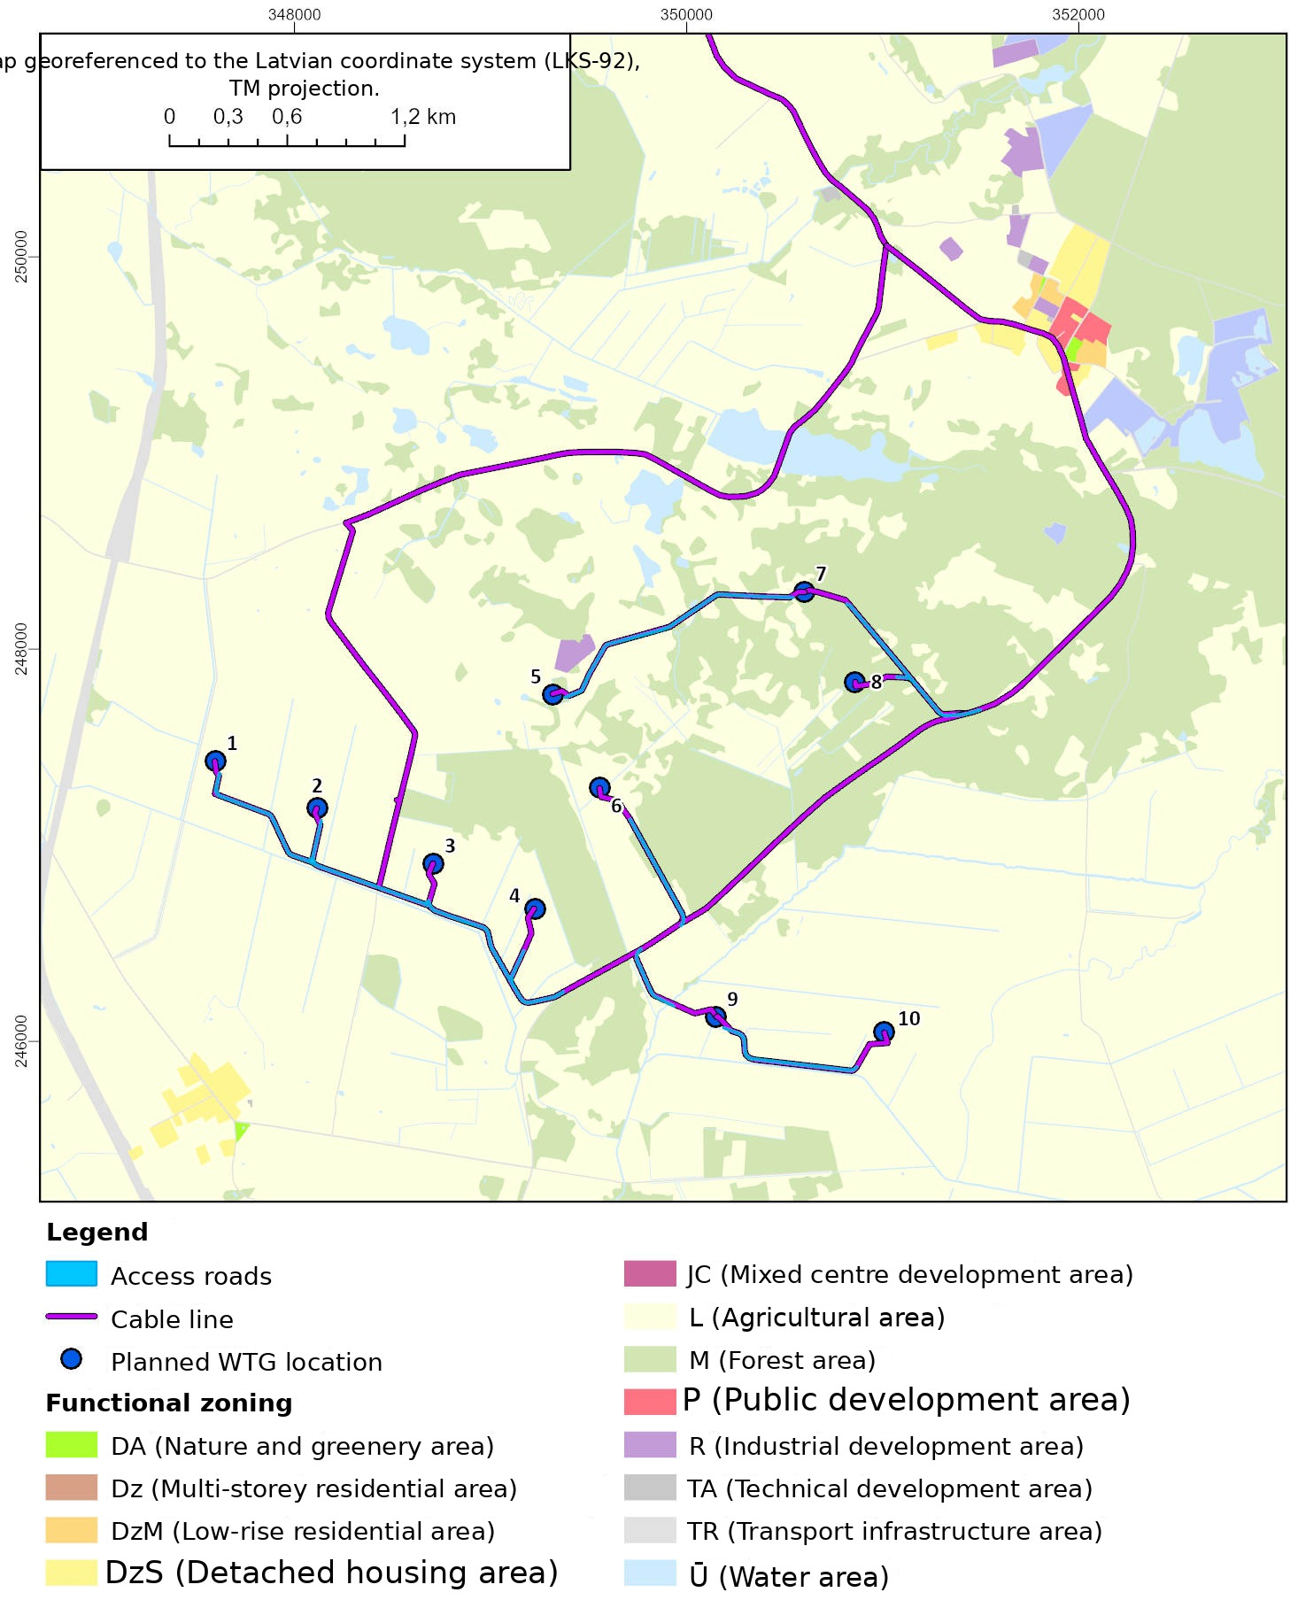
Figure 6. Functional zoning in the territory of the proposed activity (in accordance with the spatial plan of Priekule municipality in force)
At the time of preparation of the initial assessment of the planned “Smikši” wind farm, version 1.0 of the Dienvidkurzeme municipality spatial plan is available, for which public consultation took place from 23 February to 7 April 2026. On 28 May, the Dienvidkurzeme municipality local government adopted Decision No. 319 “On the refinement of version 1 of the Dienvidkurzeme municipality spatial plan and of the draft Environmental Report”.

Information on the significant environmental aspects from which the environmental impact of the proposed activity arises, their characterisation and assessment

extraction and use of natural resources (indicating the type and volume, for example, planned water consumption in cubic metres per day, month, year) and their transformation, including the areas of land to be transformed:
During the operation of the wind farm, no extraction and use of natural resources – water, mineral resources, etc. – takes place. According to the calculations, an area of 24.9 to 30.6 ha will be required for the construction of 10 WTGs and the associated infrastructure (including access roads and cable lines). Part of the territory used during construction will remain, also during the operation of the wind farm, as territory beneath structures or road infrastructure, whereas those parts of the construction sites that are not needed during the operation of the farm, and the land above the cable routes that has been used for agriculture to date, will continue to be used for the previous purpose. Deforested areas of up to 6.21 ha will not be used for forestry activity, but the lost forest land will be compensated by afforesting an equivalent area outside the WTG construction sites.

main raw materials and their quantity per year, or the planned construction materials and their quantity for the construction of the facility (indicating all hazardous chemical substances and mixtures, as well as other raw materials whose consumption exceeds 100 kg per year):
Traditional construction materials will be used for the construction of the wind farm infrastructure, for example sand, gravel and crushed stone for the construction of roads and pads, and concrete and steel for the construction of the plant foundations. The precise volume of the materials to be used will be determined during the preparation of the construction design. WTGs are not manufactured in Latvia, but all components necessary for their assembly will be delivered from production facilities in Europe. During the operation of the wind farm, various types of raw materials are not used, as would be the case in typical manufacturing sector enterprises. At the same time, it should be noted that lubricants and fluids for cooling and hydraulic systems are used in WTGs, where the quantity of these substances in one plant is typically in the range of 3.5–5.5 t.

quantity of output per year:
The “Smikši” wind farm is intended as an electricity generation facility whose total capacity could reach up to 72 MW. The amount of electricity generated (MWh/year) will depend on the selected WTG model, wind conditions and the operating restrictions of the WTGs related to reducing environmental impact, as well as technological downtime.

water supply solution, water abstraction source (existing or planned), availability of water resources at the water abstraction source to be used (surface or groundwater). Planned volume of wastewater (cubic metres per day, month, year), wastewater management solution. Heat supply solution; for a combustion plant – the planned fuel, its quantity and the capacity of the plant:
During the operation of the WTGs, no water resources or heat are consumed and no wastewater is generated.

emission of pollutants into air, water (pollutants in wastewater, their concentration before and after treatment, wastewater discharge point) and soil (pollutants and their concentration), odours:
During the operation of the WTGs, no air, soil or water pollution is generated.

waste from technological processes (including hazardous waste), by-products and the planned waste management:
It is expected that during the wind farm construction process both municipal waste and construction and production waste will be generated, whereas during operation – production waste, including worn-out components. Municipal waste generated during construction and demolition will be collected and temporarily stored in municipal waste containers, which are intended to be placed on the pads for the temporary storage of machinery, equipment and materials. The collected waste will be handed over to an operator that has obtained the necessary permits for the management of municipal and construction waste. Waste generated during operation, which mainly consists of worn-out WTG components and used lubricants and fluids for cooling and hydraulic systems, will be collected and handed over to waste management companies that have obtained the necessary permits for working with the relevant types of waste.
According to the available information, the operating life of a WTG is on average 25–30 years. After the operation of a WTG, complete demolition or reconstruction of the structure may be carried out, dismantling the above-ground part of the WTG and installing a new WTG on the existing foundations. According to the manufacturers’ estimates, the majority (85–95%) of the materials used for the construction of a WTG are already reusable today, and only a small proportion of materials is currently not recycled but incinerated in special installations.
WTG blades, which are manufactured from composite materials, are currently to be regarded as a group of materials whose recycling possibilities are at present limited. However, both WTG manufacturers and organisations associated with the wind energy sector are currently actively seeking simple, inexpensive and widely applicable solutions for the reuse of polymer materials associated with the wind energy sector.
At present it is difficult to forecast what proportion of the materials used for the construction of the WTGs it will be possible to recycle after 25–30 years, when the operating life of the WTGs draws to a close; however, it is to be assumed that the proportion of materials suitable for recycling will increase as the volume of materials available for recycling on the market grows and as technological recycling solutions are improved.

Physical impacts (for example, electromagnetic radiation, vibration, noise):
In accordance with the “Guidelines for carrying out an initial environmental impact assessment for evaluating the environmental impacts caused by the construction of wind power plants”, the following physical impacts have been assessed:
- environmental noise;
- low-frequency noise;
- shadow flicker effect.

Environmental noise
The assessment of environmental and low-frequency noise of the “Smikši” wind farm is attached in Annex 2 to the application. The assessment of the environmental noise generated by the operation of the WTGs was carried out in accordance with the requirements of Cabinet of Ministers Regulation No. 16 of 7 January 2014 “Procedure for noise assessment and management”, using the methods specified in Annex 5 to the regulations, Section 2.1 “General provisions – road traffic, railway and industrial noise”, Section 2.4 “Industrial noise”, and Section 2.5 “Calculation: noise propagation from road traffic, railway traffic and industrial sources”. For the calculation and modelling of environmental noise, the noise prediction and mapping software IMMI 2025-2 developed by Wölfel Meβsystem Software GMbH+Co K.G was used (licence number S001/00757).
With regard to environmental noise, the approach chosen was to assess the worst possible scenario, namely the loudest WTG model. Based on the calculation results, it was concluded that the highest noise emissions would be generated by the installation of Vestas V172-7.2 MW plants with STE blades. Accordingly, the noise level that would be generated by the installation of the WTG model Vestas V172-7.2 MW with STE blades on a 166 m high tower was analysed in detail with regard to environmental noise. Although the manufacturers of all WTGs analysed in this assessment also offer the use of special operating modes that ensure lower noise emission values, the possibilities of using these modes have not been assessed in this assessment in the context of environmental noise, since all the modes offered by the manufacturers are also associated with considerably lower plant efficiency indicators.
According to the calculation results, the noise level generated during the operation of this WTG model would not exceed the environmental noise limit values laid down in Cabinet of Ministers Regulation No. 16 “Procedure for noise assessment and management” in the residential development areas located near the wind farm. The highest noise level, 38 dB(A) for the night indicator, is forecast in the residential development areas “Spalvas” and “Žagāres”. It is not expected that, operating the “loudest” of the WTG models assessed within the framework of the assessment in the farm territory, the limit value recommended by the World Health Organization for noise generated by WTGs for the day-night indicator – 45 dB(A) – would be exceeded.
In carrying out the assessment, four alternatives for the location of the substations and BESS were also analysed. Taking into account that the technical parameters of the substation and BESS to be built – namely the sound power generated by the noise sources – are not yet known, the distance from the siting location of the substation and BESS to the nearest residential development areas was determined within the framework of the assessment. Using the data on the determined distance, as well as the lowest limit value applicable to these residential development areas, namely 45 dB(A) at night, including taking into account the tonal nature of the sound (+5 dB(A) in accordance with what is laid down in Cabinet of Ministers Regulation No. 16 “Procedure for noise assessment and management”), the permissible noise level at the boundary of the substation was calculated; the noise emission limits are shown in Table 18 of the assessment.
In choosing the technical solution for the substation, the initiator must take into account the calculated noise emission limit values. If the aforementioned emission limit values cannot be ensured, the substation construction site must be moved further away from residential development areas or noise reduction measures must be implemented. No other measures for reducing environmental noise are necessary.

Low-frequency noise
The assessment of environmental and low-frequency noise of the “Smikši” wind farm is attached in Annex 2 to the application. For the calculation and modelling of low-frequency noise, the WindPro 4.2 program developed by EMD International was used, which is designed for assessing the impacts generated by WTGs and includes a special module for calculating low-frequency noise in accordance with the requirements of Order No. 995 of the Danish Ministry of Environment and Food. The limit values established in Denmark were used for the assessment, as recommended by the guidelines issued in Latvia for the assessment of wind farm impacts. The aforementioned order and the guidelines provide that the total low-frequency (10–160 Hz) noise level generated by WTGs in residential buildings must not exceed 20 dB at wind speeds of 6 m/s and 8 m/s (at a height of 10 m above ground).
Unlike environmental noise, whose dispersion is mainly influenced by atmospheric absorption indicators, the level of low-frequency noise indoors is also influenced by the characteristics of the sound insulation capacity of the façade, which may differ sharply for sounds of particular frequencies; therefore, low-frequency noise calculations were carried out for all the assessed WTGs.
According to the calculation results, if any of the assessed WTG models is built in the “Smikši” wind farm, it is not expected that the low-frequency noise limit value established in Denmark – 20 dB at wind speeds of 6 m/s and 8 m/s (at a height of 10 m above ground) – could be exceeded in the residential buildings located nearby. The highest forecast low-frequency noise level, irrespective of the technological alternative, is expected at the nearest located residential building – “Spalvas” – where, if the WTG model with the highest low-frequency noise emission, Nordex N175-6.8 MW, is built in the farm territory, it could reach 17.8 dB(A).
In carrying out the low-frequency noise assessment, it was found that there are no grounds for imposing restrictions on any of the technological alternatives assessed in the assessment, since according to the calculation results their operation would not result in the 20 dB(A) limit value being exceeded in the residential buildings located nearby.

Shadow flicker
The shadow flicker effect calculations for the “Smikši” wind farm are attached in Annex 3 to the application. For the calculation and modelling of the shadow flicker effect, the WindPro 4.2 program developed by EMD International was used, which is designed for assessing the impacts generated by WTGs and includes a special module for calculating the duration of shadow flicker impact. In carrying out the calculations, data from the ERA5 model developed by the European Centre for Medium-Range Weather Forecasts (ECMWF) on wind speed and wind direction in the territory of the proposed activity for the period from 1 January 2016 to 31 December 2025 were used. In carrying out the calculations according to the real-time scenario, data on the average duration of sunshine recorded at the state network meteorological observation station “Liepāja” (the nearest meteorological observation station at which such observations are made) were used. All 6 technological alternatives were assessed in the assessment process. The impact of the shadow flicker effect was assessed for residential and public buildings located up to 3 km from the planned WTGs. In the calculation model, the aforementioned buildings are defined as points whose windows face perpendicular to all the planned WTGs (the “greenhouse” approach).
In Latvia, no regulatory enactments have been developed that would regulate how the impact of the shadow flicker effect is to be assessed, or that would establish limit values which must not be exceeded. In the guidelines on the impacts generated by wind farms, their assessment and limitation, developed in 2023, the shadow flicker effect has been identified as one of the negative impact factors associated with the operation of WTGs. Most countries that have established limit values base them on the limit values of the guidelines developed in Germany and use the calculation methods developed in Germany for assessing the duration of the shadow flicker impact. Also in the Guidelines for carrying out an initial environmental impact assessment for evaluating the environmental impacts caused by the construction of wind power plants, developed by the State Environmental Service in 2023, it is recommended to use the following limit values for the duration of the shadow flicker impact, which have also been used in this assessment:
- no more than 30 flicker hours per year, if calculated according to the worst-case scenario method;
- no more than 8 flicker hours per year, if calculated according to the probable scenario;
- no more than 30 flicker minutes in any one day, where either of the assessment scenarios is used.
The duration of the shadow flicker impact is assessed using two methods: the worst-case scenario and the real scenario methods. When calculating the duration of the shadow flicker impact according to the worst-case scenario method, it is assumed that the sun shines constantly during the daylight hours and is always positioned perpendicular to the rotor blades, which are in continuous motion. When calculating the duration of the shadow flicker impact according to the real situation scenario method, the total duration of the flicker impact is calculated on the basis of historical observation data on the duration of sunshine, wind speed and direction in the specific territory.
The impact of the shadow flicker effect, taking into account the worst-case scenario method (assuming that the sun shines constantly during daylight hours and is always positioned perpendicular to the rotor blades, which are in continuous motion), may be exceeded at 34 residential buildings if the technological alternative with the greatest impact (Siemens Gamesa SG170) is chosen. Likewise, the aforementioned technological alternative for the Siemens Gamesa model generates the greatest impact with regard to the limit values of the real-time scenario method – they may be exceeded at 56 residential buildings. The residential buildings at which exceedances of the limit values for the duration of the shadow flicker impact are forecast are shown in Table 5. The calculation files for the shadow flicker impact are attached in Annex 3.

Table 5. Residential buildings at which exceedance of the limit values for the duration of the shadow flicker impact is forecast
Name or address | Cadastral designation of the building | Maximum possible duration of flicker impact per year (hh:mm) | Maximum possible flicker duration per day (hh:mm) | Statistically probable duration of flicker impact per year (hh:mm)
Smilši | 64580010015001 | 261:45 | 1:58 | 142:21
Nuļļi | 64580010231001 | 288:08 | 1:38 | 102:11
Ķempji | 64640040168001 | 134:39 | 1:08 | 77:43
Žagāres | 64640030014001 | 170:25 | 2:04 | 28:57
Cemetery house | 64580010003001 | 89:49 | 1:05 | 28:55
Āboli | 64640040068001 | 45:11 | 0:30 | 26:13
Kļaviņas | 64640030015001 | 163:14 | 1:59 | 24:53
Skudriņi | 64640040148001 | 40:23 | 0:39 | 23:02
Caunītes | 64580010232001 | 96:15 | 0:47 | 22:17
Plēsumnieki | 64640040064001 | 36:00 | 0:34 | 19:29
Spalvas | 64640040116001 | 31:04 | 0:35 | 17:18
Apes | 64640040058001 | 29:03 | 0:26 | 17:03
Apes 1 | 64640040059001 | 27:38 | 0:25 | 16:14
Ķera Ostnieki | 64640040123001 | 26:00 | 0:25 | 15:19
Krieviņi | 64640040082001 | 25:48 | 0:27 | 15:05
Indrāni | 64580010263001 | 30:04 | 0:49 | 14:59
Dzeguzes | 64640030007001 | 100:11 | 1:36 | 14:34
Puži | 64640030010001 | 96:32 | 1:36 | 14:21
Kalnāji | 64640030003001 | 75:19 | 0:47 | 13:42
Alpēni | 64640040006001 | 22:52 | 0:25 | 13:06
Jaunarāji | 64640030013001 | 58:58 | 0:42 | 12:23
Vējkalni | 64640040073001 | 20:45 | 0:23 | 12:12
Strazdiņi | 64640040072001 | 20:33 | 0:23 | 12:07
Apsītes | 64580010259001 | 28:24 | 0:55 | 12:01
Liekņi | 64640020012001 | 25:42 | 0:32 | 11:54
Austrumi | 64640040071001 | 19:45 | 0:23 | 11:40
Zaķīši | 64640040079001 | 19:47 | 0:22 | 11:38
Ceļmalas | 64640040045001 | 19:28 | 0:22 | 11:30
Rasas | 64640030005001 | 63:06 | 0:47 | 11:23
Smilgas | 64640040046001 | 19:19 | 0:22 | 11:22
Salnas | 64640030012001 | 62:15 | 0:50 | 11:07
Dzintari | 64580010251001 | 33:36 | 0:32 | 11:04
Ceriņi | 64640040077001 | 18:26 | 0:22 | 10:49
Lazdas | 64640040075001 | 18:10 | 0:22 | 10:39
Vizbulīši | 64640040070001 | 17:48 | 0:23 | 10:33
Ozoli | 64640040007001 | 17:40 | 0:23 | 10:28
Līčupes | 64580010395001 | 30:08 | 0:48 | 10:19
Niedras | 64640030008001 | 65:19 | 1:10 | 10:08
Smilts Lūķi | 64580010027001 | 25:23 | 0:25 | 9:11
Oškalni | 64640040047001 | 15:29 | 0:21 | 9:03
Līgotņi | 64640020069001 | 18:41 | 0:29 | 8:52
Valteri | 64640040060001 | 15:26 | 0:23 | 8:48
Tūbeļi | 64640040139001 | 15:20 | 0:27 | 8:46
Upes Lūķi | 64580010275001 | 20:25 | 0:22 | 8:23
Jaunozoli | 64640040050001 | 14:09 | 0:19 | 8:19
Pepiņi | 64640040055001 | 14:03 | 0:22 | 8:10
Bērziņi | 64580010253001 | 26:39 | 0:34 | 7:46
Krieviņi | 64580010188001 | 54:37 | 0:41 | 7:36
Rūķi | 64640030019001 | 40:01 | 0:37 | 7:21
Brieži | 64640020005001 | 17:01 | 0:30 | 6:56
Siksnas | 64580010194001 | 57:08 | 1:07 | 6:41
Lemkini | 64580010020001 | 52:37 | 0:55 | 6:23
Dravinieki | 64580010192001 | 43:50 | 0:52 | 5:16
Zvaguļi | 64580010063001 | 34:29 | 0:30 | 5:06
Dižeglītes | 64580010190001 | 30:38 | 0:29 | 3:46
Brūveri | 64640030028001 | 21:04 | 0:30 | 3:45
Uzvaras iela 23 | 64580010136001 | 21:33 | 0:30 | 2:24

Although in Latvia no limit values for the permissible duration of the shadow flicker impact have been established by regulatory enactments, it is recommended that the wind farm be operated in such a way that its operation does not result in the limit values established in the aforementioned guidelines being exceeded. The only technical solution that is possible in order to ensure that the established limit values for the duration of the flicker impact are not exceeded at residential and public buildings is the shutdown of WTG operation at those times when the shadow flicker effect is generated. Based on the calculation results of the shadow flicker assessment, it is possible to determine precisely the time periods during which the operation of particular WTGs must be stopped in order to prevent or reduce the duration of the shadow flicker impact at all residential and public buildings in the vicinity of the wind farm.
By using one of the aforementioned modes, it is possible to reduce and prevent the negative impact generated by the WTGs that is associated with the shadow flicker effect. The initiator envisages that the “Smikši” wind farm will be operated in such a way that the duration of the shadow flicker impact generated by the WTGs at residential and public buildings does not exceed the limit values established in the guidelines. The mitigation measures are applicable to all wind power plants and all technological alternatives, whereas a precise plan for reducing the duration of the flicker impact (a plant shutdown calendar) must be included in the construction design once a specific plant model has been chosen and the construction sites of the plants are precisely known.

Environmental risk and emergency situations
The assessment of environmental risk and emergency situations of the “Smikši” wind farm is attached in Annex 4 to the application. Following the recommendations provided in the “Guidelines for carrying out an initial environmental impact assessment for evaluating the environmental impacts caused by the construction of wind power plants”, several potential hazards associated with the operation of WTGs have been identified:
- formation of ice on the WTG rotor blades with the subsequent fall of pieces of ice in the vicinity of the installation;
- mechanical damage/collapse of the WTG with the effect of the spread of equipment fragments in its vicinity;
- defects of the lubrication system with an oil leak;
- WTG fires.
An environmental risk assessment has also been carried out for the BESS construction sites, taking into account possible technological accidents at the BESS.
In Latvia, no procedure, principles or criteria for assessing WTG accident risks have been established; accordingly, the experience of other countries and the guidelines developed by them in this field have been used for assessing the planned situation. One of the leading countries in Europe in industrial risk assessment and in the use of risk assessment results for spatial planning purposes is the Netherlands. As in the case of any other industrial facility, the state institutions of the Netherlands also require an accident risk analysis to be carried out for WTG construction projects. The method developed in the Netherlands has also been used as a basis for the preparation of its WTG risk assessment manual by the department of regional development, environmental planning and projects of the Belgian Ministry of the Environment. Taking into account that the Belgian department of environmental planning and projects has also issued calculation sheets (calculation modules) developed on the basis of this method, which facilitate the application of the method, the Belgian WTG risk assessment manual and the associated calculation modules were used for the preparation of this risk assessment. Within the framework of the assessment, a detailed accident risk assessment was carried out for all three WTG models, comparing them with one another from the point of view of accident risk.
For assessing the hazard generated by accidents associated with the BESS and for characterising the risk, the following were used: the Netherlands PGS 37.1 guidelines, which lay down measures for controlling the risks of lithium-containing energy storage systems on the basis of an analysis of the risks of possible scenarios; the calculation method developed by the Netherlands National Institute for Public Health and the Environment for assessing the risk of lithium-containing energy carriers; and a study on lithium-containing energy carriers issued by the Netherlands Ministry of Infrastructure and Water Management in connection with the development of this method (hereinafter – the Netherlands study). For assessing the potential hazard of the BESS of the proposed “Smikši” wind farm, computer modelling of the spread of the consequences of possible accidents was carried out using the accident consequence spread modelling computer program Effects (version 13.0.1) of the company Gexcon AS (SIA “Estonian, Latvian & Lithuanian Environment” licence ID 66730890787096783).
In assessing the ice fall risk of the “Smikši” wind farm, a simplified trajectory model is used, which calculates potential impact distances on the basis of the mass of the piece of ice, its initial velocity and environmental parameters (wind speed, wind direction, fall height). Conservative assumptions ensure sufficient accuracy while reducing the volume of input data and resource consumption required. The simplified trajectory model makes it possible to identify potential risk zones quickly and to determine the necessary protective measures, while maintaining compliance with the requirements of regulatory enactments.
In managing environmental risk and emergency situations, it is important not only to assess the risks directly associated with the operation of the wind farm, but also to identify circumstances in which the simultaneous presence of various facilities in a territory may contribute to the emergence of cumulative impacts. Assessing the information on other high-hazard facilities and facilities associated with the performance of economic activity in the vicinity of the territory of the proposed “Smikši” wind farm and of the BESS construction sites, it was found that, at the time of preparation of the assessment, there are no high-hazard facilities included in Cabinet of Ministers Regulation No. 46 of 21 January 2021 “List of high-hazard facilities” in the vicinity of the territory of the proposed activity.
Since the total installed capacity of the wind farm will not exceed 100 MW (the planned capacity is up to 72 MW), Cabinet of Ministers Regulation No. 563 of 19 September 2017 “Procedure for the identification and determination of high-hazard facilities, as well as for the planning and implementation of civil protection and disaster management” is not applicable to the facility, and there will also be no binding requirement to develop a civil protection plan for a high-hazard facility.
Summarising the information provided above and the calculations carried out on risk zones and the distances of direct impact of accident consequences, the recommended safety distances around WTGs are as follows:
- 87.5 m – a zone of economic activity restrictions in which it is not recommended to establish permanent workplaces (based on the largest rotor diameter considered and the potential for direct impact of accident consequences in the rotor operating zone);
- 263 m – recommended distance to state main roads (based on the recommendations of the Belgian risk assessment guidelines and the calculations carried out);
- 317 m – recommended distance to state roads of all types and to local government roads, provided that no technical solutions for reducing environmental risks are introduced (based on the furthest ice fall distance);
  - By introducing technical solutions for reducing environmental risks, the distance may be reduced to:
  - state main roads – 263 m;
  - local government roads – 87.5 m.
- 721 m – a zone restricting the siting of high-hazard facilities (based on calculations carried out according to the recommendations of the Belgian risk assessment guidelines);
- 800 m – distance from residential and public buildings (based on Cabinet of Ministers Regulation No. 240).

In carrying out the accident risk assessment, no limiting factors were identified on account of which any of the assessed WTG construction sites should be regarded as unfeasible. Summarising the information on the recommendations regarding the applicable safety distances in the case of the use of the assessed WTG models and analysing the territories affected by them, we recommend setting the following conditions for the implementation of the proposed activity:
- The total capacity of the proposed “Smikši” wind farm does not reach 100 MW; accordingly, the requirements of Cabinet of Ministers Regulation No. 563 of 19 September 2017 “Procedure for the identification and determination of high-hazard facilities, as well as for the planning and implementation of civil protection and disaster management” are not binding on it and it is not required to develop a civil protection plan for a high-hazard facility. However, taking into account that the WTGs planned in the wind farm are intended to be sited in a territory with a comparatively dense network of drainage ditches and, in individual cases, also close to watercourses of national significance, a preparedness and response document must be provided for, including procedures for actions in the event of an accident – the procedure for prompt response in the event of an oil leak or a plant accident, which will include the measures to be taken and the procedure for limiting the spread of an oil spill and for collecting the spilled oil. The actions must also cover measures for responding to a fire at a WTG or at the BESS, as well as informing the public and communicating with the parties involved in the event of an accident.
- Within the 721 m safety distance from the intended WTG locations, determined in accordance with the recommendations of the Belgian risk assessment guidelines, there are no above-ground high-hazard facilities. However, although this condition is not directly applicable to the “Smikši” wind farm, in the opinion of the developers of the risk assessment, in continuing the development of the territory and planning the siting of other facilities in the future in the vicinity of the planned WTGs, the hazard potential generated by the plants must be taken into account.
- It was found that the operation of the proposed wind farm will not create a hazard to state main roads; however, local government roads are located within the ice dispersal zone, and accordingly there are grounds for imposing a requirement to implement technical solutions for reducing environmental risks for the siting of WTGs Nos. 3 and 5 at the locations intended for them. WTGs Nos. 3 and 5 must be equipped with ice detection or anti-icing systems and with systems for stopping the operation of the plants in the event of icing.
- The maximum horizontal distance from the tower to the tip of the rotor blade (for the models Nordex N175 – 7.0 MW and Enercon E175-7.0 MW) is 87.5 m, and it is recommended that this distance be established as a zone in which economic activity is restricted. Although the movement of people and the carrying out of economic activity within the aforementioned zone do not create a direct and continuous hazard to human health or life, the siting of permanent workplaces in this territory is not recommended. At the same time, it is important to ensure appropriate information about the operational risks, particularly if there is a possibility of icing, and in such circumstances restricted access to the power plant must be provided for. Personnel providing technical servicing of the wind power plants must be instructed in accordance with labour protection and safety requirements, whereas, based on the results of the working environment risk assessment, the issuance of appropriate personal protective equipment must be provided for in order to ensure the safety and health protection of employees during operation and maintenance works.
- In none of the location alternatives considered is the intended BESS location such that, in the event of an accident involving a BESS container, the possible spread of consequences hazardous to human life could reach residential development. At the same time, the operational safety of the BESS in the case of alternative A may be affected by a WTG accident, since the BESS is intended to be located within the zone of possible consequence dispersal in the event of an accident at WTGs Nos. 2 and 3, whereas in the case of location alternatives B, C and D there is a power line near the BESS, in the event of mechanical damage to which the BESS could be affected. Taking this into account, when carrying out design there are grounds for considering suitable solutions for protecting the BESS from external effects.

Impact on communication equipment
In accordance with the “Guidelines for carrying out an initial environmental impact assessment for evaluating the environmental impacts caused by the construction of wind power plants”, the initiator has consulted VAS “Latvijas gaisa satiksme” (Latvian Air Traffic) on the impact of the planned wind farm on air traffic surveillance equipment. In carrying out the initial assessment of the construction intention, VAS “Latvijas gaisa satiksme” concluded that the LGS secondary surveillance system WAM/ADS-B MLAT receiving station Virga (L21_VIRG) is located near the planned wind farm. VAS “Latvijas gaisa satiksme” does not object to the refined layout of the wind turbines of the “Smikši” wind farm and to the further advancement of this project, provided that the conditions specified in LGS letter No. VI-AD/JPN-03/2024/180 of 7 March 2024 are fulfilled. The letter of VAS “Latvijas gaisa satiksme” is attached in Annex 5 to the application.

Information on the possibilities of adapting the technological solution of the proposed activity for carbon dioxide capture, if the construction of a combustion plant with an electricity generation capacity of 300 MW or more is envisaged
Not applicable to the proposed activity.

Impact on natural values:
According to the information available in the Nature Data Management System “Ozols”, the study area does not include specially protected nature territories (hereinafter – SPNT) or micro-reserves. The nearest SPNT is the dendrological planting “Kalēti Park”, located approximately 2 km north-west of WTG 1, whereas approximately 4.5 km north-east of WTG 9 and WTG 10 is the nature reserve “Ruņupes ieleja”, which is also a type B Natura 2000 site, established for the protection of specially protected species (other than birds) and biotopes. Approximately 2 km from the planned WTG park, in Lithuania, there are two Natura 2000 sites – “Apšės upės slėnis” (LTSKUB001), established for the protection of the corncrake, and “Apšės upė ir jos slėnis” (LTSKU0010), established for the protection of biotopes.
Within 5.0 km of the planned WTG park there are eight micro-reserves established for the protection of specially protected bird species. The nearest micro-reserve (No. 2765), established for the protection of the lesser spotted eagle, is located approximately 2.8 km from WTG 8 (see Figure 7).
According to the assessment of the biotope experts, the implementation of the proposed activity does not create a threat to ensuring the conservation objectives of protected nature territories or to ensuring the integrity of protected territories, either on a local or a regional scale. The bat and bird experts have likewise not identified circumstances that would indicate a significant negative impact of the proposed activity on bat and bird populations in the SPNTs located near the farm.

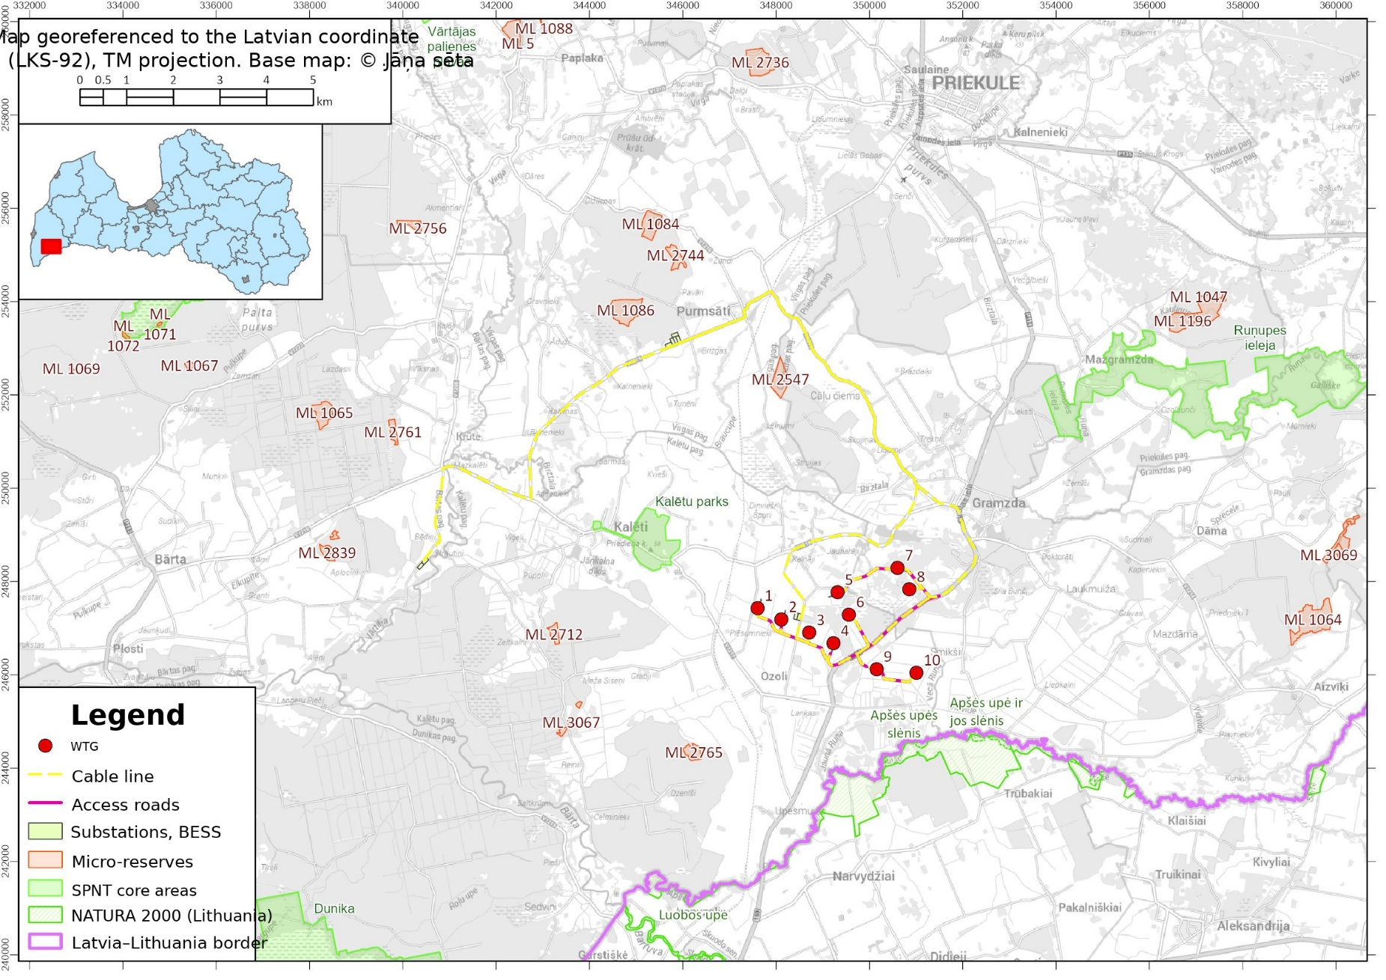
Figure 7. Specially protected nature territories and micro-reserves in the vicinity of the planned “Smikši” wind farm

10.1. Biotopes of European Union significance
The opinion of the biotope experts is attached in Annex 6 to the application.
Information on the biotopes specially protected in Latvia and the European Union and the localities of specially protected (hereinafter – SP) species occurring in the study area or in its vicinity was obtained by compiling information from the data available in the Nature Data Management System “Ozols”, as well as by carrying out field surveys of the territory. During the surveys it was checked whether the biotopes included in the “Ozols” system can be identified in the field; in cases where the proposed activity could have a direct or indirect impact on biotopes, their characteristics and the nature of the possible impacts were assessed in greater detail. An overview of the types of biotopes and protected species located in the study area is provided in the experts’ opinion. The surveys in the 2025 season were carried out by experts certified by the Nature Conservation Agency – Toms Daniels Čakars, Margita Deičmane and Gune Mīlgrāve.
In total, nine types of biotopes of EU significance were identified in the study area, occurring scattered throughout the study area. Localities of SP lichen and invertebrate species associated with the types of protected biotopes within the experts’ competence were identified in the territory – Arthonia spadicea, Arthonia vinosa, Chaenotheca chlorella, Lasius fuliginosus, Protaetia (Liocola) marmorata and Osmoderma barnabita (eremita). Detailed information on the species localities is included in the experts’ opinion.
As other values significant for the conservation of biological diversity and the landscape of the surveyed territory, ancient (veteran) trees, potential veteran trees and large-dimension trees were identified, which may be potential habitats of SP species. In total, 5 veteran trees, 4 potential veteran trees and 16 large-dimension trees were identified in the study area or in its vicinity, as well as such natural values as the tree avenues in Purmsāti and Gramzda.
In the construction of WTGs, the factors threatening natural values with regard to SP species localities and protected biotopes, as well as other natural values, may be:
- direct destruction of SP species habitats and potential habitats (large-dimension trees), as well as of biotopes of EU significance, within the zone of direct impact of the WTGs;
- indirect impact on the hydrology of forest biotopes as a result of the construction or deepening of ditches. The impact distance is assumed in accordance with the guidelines on the assessment of the impact of forest roads and drainage systems, assuming that the maximum depth of side ditches around infrastructure facilities may be up to 1.5 m.
Assessing the intended WTG construction sites, the planned cable routes and the construction sites of the new roads and the natural values present at them, the experts identified impacts that can be prevented or mitigated by carrying out various measures. For the planned WTGs Nos. 7 and 8, a slight possible negative impact on a local scale on protected natural values was identified; a negative impact was also identified for individual sections of the cable route. The possible impact on protected biotopes, specially protected species and natural values and the measures for mitigating the impact are compiled in Table 5 of Annex 6.
With regard to the impact on protected biotopes and species localities, WTGs 7 and 8 should be highlighted, as well as the sections of the cable line near biologically valuable trees or avenues. In the implementation of the construction of the WTGs and the cable line sections, an insignificant impact on a regional and national scale is foreseeable, but locally, within the forest massif – a slight negative impact. In order to avoid the negative impact on natural values in the construction of the WTGs as far as possible, the experts have recommended:
- In the construction of WTG No. 7 and of the substation, it is recommended to preserve the biologically valuable trees (marked in the maps of Annex 6 as DV 16 and DV 11).
- In the construction of WTG No. 8, observing precautionary measures, it is recommended to plan the site on an embankment, without providing for the construction of ditches.
- In places where the cable line crosses the freshwater biotopes 3260_1 Fast-flowing river stretches and natural river sections, the construction of the cable line is to be carried out using the horizontal directional drilling method.
- In places where veteran trees, potential veteran trees and biologically valuable trees, as well as avenues, have been identified in the areas adjoining the cable line and the access road, the construction of the cable line is to be planned on the other side of the identified natural values or observing the recommended distance from the trees (10 m from potential veteran trees and biologically valuable trees; 10 m from the crown projection of a veteran tree).
- In places where grassland biotopes have been identified in the areas adjoining the cable line and the access road, no excavation works are to be carried out and no material stockpiles, soil dumps or vehicle movement are to be planned within the area of the grassland biotope.
The opinion of the biotope experts also includes other recommendations for the construction of the infrastructure. If, during the development of the construction design, it is necessary to refine or change the planned WTG construction pads, access roads or electricity transmission network (cable) construction sites, then a repeated assessment must be carried out of the possible impact of the refined or changed implementation sites of the proposed activity on the localities of specially protected species and on the areas of protected biotopes.

10.2. Ornithofauna
The bird experts carried out research in the territory of the planned wind farm and its surroundings during the period from 23 December 2024 to 2 December 2025 and from 24 April 2026 to 12 June 2026, carrying out surveys of the territory, bird counts, checking known large nests and recording new ones, as well as passive acoustic monitoring. The surveys were carried out by experts certified by the Nature Conservation Agency – Elīna Gulbe, Mareks Kilups, Jānis Ukass, Elza Marija Zacmane, Ivo Dinsbergs – as well as by experienced bird surveyors Ilze Bojāre, Jānis Jansons, Artūrs Bilerts and Emīls Kuplais. Based both on previously recorded bird observations and on those identified during field surveys, as well as on information provided by AS Latvijas Valsts meži, an ornithologists’ opinion was prepared, in which the impact of the construction and operation of the “Smikši” wind farm on ornithofauna was assessed. In the opinion prepared, the feasibility of constructing up to 14 WTGs was initially assessed. However, based on the assessment of the ornithologists and other experts, in order to reduce the potential environmental impact, the number of plants intended for construction was reduced to 10. The main research was carried out within a 2 km zone around the planned WTGs. The ornithologists’ opinion is attached in Annex 7 to the application.
Overall, the wind farm territory is comparatively poor in natural values; however, suitable habitats for several specially protected bird species are present in this territory. Observation data and passive acoustic monitoring data indicate that no particularly significant bird migration routes cross the territory.
During the research, 32 specially protected or rare bird species were identified in the wind farm territory and its surroundings, of which for 11 species the observation was determined to be of an incidental nature. For 19 species, further monitoring or mitigation measures are to be carried out. The spring results of the passive acoustic monitoring carried out confirm the presence of 13 specially protected species and of the common buzzard Buteo buteo in the wind farm study area, whereas in the autumn of 2025 a total of 5 specially protected species were identified.
According to the assessment prepared with regard to habitats suitable for birds, the greatest impact is expected on the habitats of the red kite, whose nesting was, however, not identified in the study area or in its immediate vicinity.
The potential threats to ornithofauna from the construction and operation of the wind farm include the following risks:
- risk of collision with rotors;
- flicker and visually observable rotor operation, which may disturb birds;
- barrier effect, which restricts bird movement;
- cumulative impact, taking into account other wind farms;
- destruction of bird habitats when carrying out construction works and creating infrastructure.
The ornithologists have defined the following risk zones in the wind farm:
- a high-risk zone, in which the construction of WTGs without mitigation measures is not permissible, and their siting in this zone creates a greater threat to the bird nesting territories identified at the time of the research;
- a risk zone, in which it is recommended to equip the WTGs with a bird protection system.
WTGs Nos. 6, 8, 9 and 10 are located within a high-risk impact zone (see Figure 8) established around a white stork nest. WTGs Nos. 9 and 10 are indeed located within the high-risk zone for the white stork; however, they are located only slightly less than 1 km from the nearest white stork nests, which is close to the high-risk zone limit value accepted in practice. Provided that the WTGs are equipped with detection systems that identify the approach of a white stork and stop the operation of the plant or substantially reduce the rotational speed of the blades, their construction is, in the opinion of the ornithologists, permissible.
WTGs Nos. 4, 6, 8, 9 and 10 are located within a high-risk zone for the lesser spotted eagle; however, as far as possible they have been moved away from the identified nest and approach the high-risk zone limit value accepted in practice. Taking into account the high collision risk characteristic of this species, for the protection of the lesser spotted eagle it is essential to ensure that the wind power plants are equipped with cameras that detect the approach of birds and stop the rotation of the rotor when birds come critically close; this is to be established as a mandatory requirement in developing the wind farm. In further bird monitoring, particular attention must be paid to this species and, if its increased presence in the territory (especially nesting) is identified, a decision must be taken on the necessary additional protection measures.
In order to reduce the potential impact on bird species and to ensure the protection of specially protected bird species, in accordance with the recommendations of the ornithologists, the following measures must be implemented:
- All WTGs must be equipped with cameras that identify birds by species or species group and stop the operation of the rotor when a bird approaches within a critical distance.
- Forest clearing works and the construction of access roads and electricity supply infrastructure must be carried out outside the nesting period of the common buzzard (01.03. – 31.07.). When carrying out deforestation, large nests must not be felled, and a group of trees and the undergrowth must be preserved around them.
- In order to assess potential changes, ornithofauna monitoring must be carried out, commencing it one year before construction and continuing during the operating period of the WTG park for the first five years, then in the seventh and tenth years. The monitoring results are to be submitted to the competent institution. Within the framework of the bird monitoring, it is recommended to carry out the following activities:
- counts of large soaring birds (diurnal raptors and the black stork) during the nesting season from points with good visibility;
- checking and searching for large nests (checking black stork, white-tailed eagle and lesser spotted eagle nests within 3 km of the wind power plants; checking other large nests at least within 1 km of the wind power plants);
- monitoring of owls (only the pygmy owl);
- monitoring of woodpeckers (in accordance with the priority protected territories defined in the Woodpecker Protection Plan);
- monitoring of corncrakes;
- monitoring of white stork breeding success;
- spring and autumn migration observations;
- during migration, it is recommended to carry out passive acoustic monitoring (PAM), placing several audio recorders in the territory.
- In continuing work on the development of the WTG park, a detailed bird monitoring plan must be developed.
Provided that the aforementioned measures are observed, it is forecast that the construction and operation of the wind farm will not create a significant negative impact on the nesting bird species and migrating bird populations in the territory.

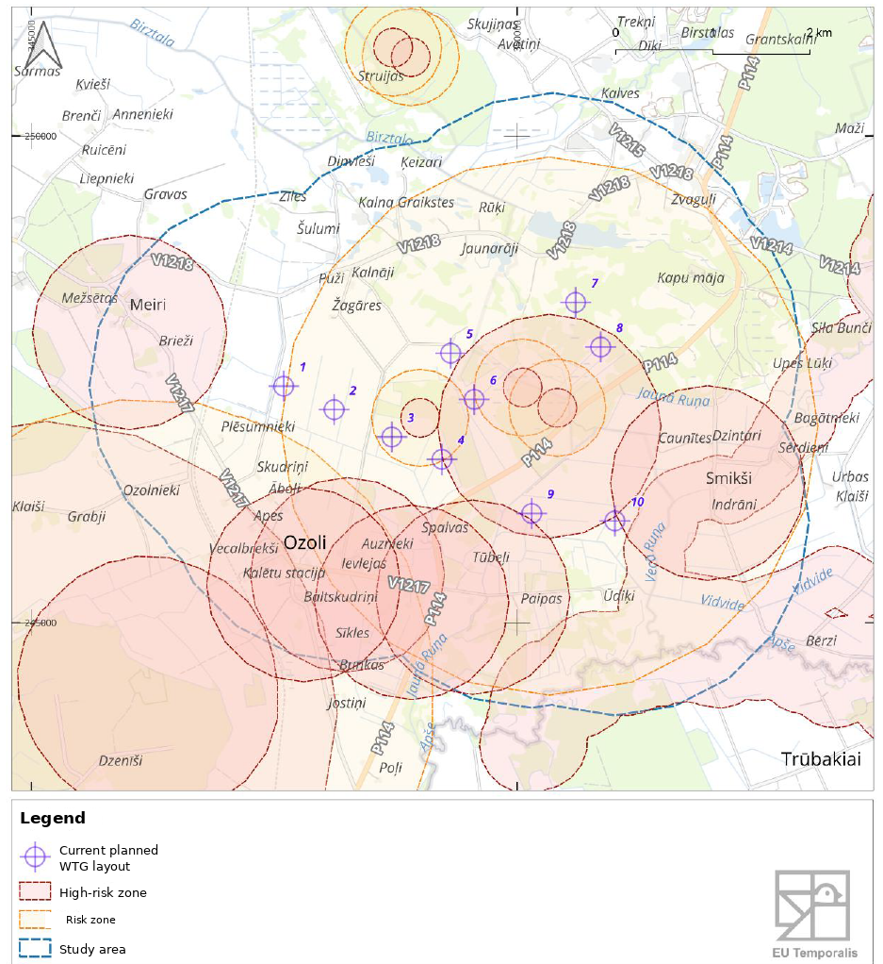
Figure 8. Distribution of risk zones for specially protected and migrating bird species.

10.3. Bats
In order to assess the impact of the planned “Smikši” wind farm on bats, bat counts have been carried out in the vicinity of the proposed activity. The surveys in the 2025 season were carried out by experts certified by the Nature Conservation Agency – Gunārs Pētersons and Jurģis Šuba. In the opinion prepared by the experts, the construction of 10 potential WTGs was assessed, taking into account the “Guidelines for assessing the impact of wind power plants on bats” developed by the Latvian Bat Research Society in 2022. In order to reflect the spring migration, breeding period and autumn migration of bats, as well as to characterise seasonal variation in activity, acoustic surveys of bats at the stations and along the route were carried out seven times per season. The bat expert’s opinion is attached in Annex 8.
Bat audio recording surveys were carried out at eight selected station locations and along one route. Six bat species were reliably identified in the territory of the proposed activity: northern bat Eptesicus nilssonii, common noctule Nyctalus noctula, Nathusius’ pipistrelle Pipistrellus nathusii, parti-coloured bat Vespertilio murinus, soprano pipistrelle Pipistrellus pygmaeus, and brown long-eared bat Plecotus auritus, as well as individuals of the genus Myotis not identified to species level. In the survey results along the routes/at the stations, the dominant species are the northern bat (69.9/32.6%), the common noctule (7.2/28.4%) and the brown long-eared bat (0/20.7%).
Overall, bat activity at night was relatively high throughout almost the entire night, with the highest activity observed at the station located in the clear-cut near WTG No. 8. In the route survey, an average of 5 bat passes per hour were recorded, which corresponds to a low activity indicator. The results are explained by the fact that the route included only agricultural landscape, where bat activity is lower.
Overall, the data of the study carried out indicate that bat activity in the study territory is high; therefore, the construction of WTGs in this territory is permissible only with the implementation of mitigation and compensatory measures. The bat experts’ opinion (Annex 8) specifies the requirements and activities associated with the conservation of habitats important for bats and with preventing or reducing the collision risk during the construction and operation of the WTGs. The operation of the WTGs is permissible only with the following WTG operating restrictions and conditions:
- For WTGs Nos. 1, 2, 9, 10, shutdown or non-start-up of turbine operation is ensured from 1 May to 30 September, from sunset to sunrise, if simultaneously:
- the wind speed at nacelle height is 5 m/s or less;
- the air temperature exceeds 10 °C;
- the amount of precipitation does not exceed 1 mm/h.
- For WTGs Nos. 3, 4, 5, 6, 7, 8, shutdown or non-start-up of turbine operation is ensured from 1 August to 31 September, from sunset to sunrise, if simultaneously:
- the wind speed at nacelle height is 6 m/s or less;
- the air temperature exceeds 10 °C;
- the amount of precipitation does not exceed 1 mm/h.
- Bat monitoring is ensured after the commencement of WTG operation. The monitoring is carried out by a certified bat species expert; the methodology includes:
- acoustic monitoring with ultrasound detectors, which, following the experts’ recommendation, are installed in the nacelles and in the middle part of the tower of at least four WTGs, as well as repeating the acoustic survey at the same stations and along the route for comparison;
- counts of dead bats beneath selected wind turbines, carried out for at least the first two years after the construction of the WTGs and the commencement of operation, at least 22 times per season.
In accordance with the monitoring results, the WTG operating restrictions may be changed each year. Monitoring must be carried out for as long as it takes to find such WTG operating restrictions whose implementation results in the bat mortality estimate not exceeding the established threshold value (two individuals per turbine per year) for two years.

Impact on landscape quality and cultural-historical objects:
Several state and local cultural monuments and their protection zones are located near the territory of the “Smikši” wind farm (see Figure 4). The following cultural monuments are located within 2 km:
- Cultural monument of national significance Ozoli ancient burial ground (protection no. 1348)
- Cultural monument of national significance Lanki ancient burial ground (protection no. 1347)
- Cultural monument of local significance Pilskalns (hill fort) (protection no. 1334)
Likewise, the protection zones of the following cultural monuments are located within 2 km:
- Cultural monument of national significance Sauši settlement (protection no. 1351)
- Cultural monument of national significance Upīši ancient burial ground (protection no. 1339)
- Cultural monument of regional significance Rači settlement (protection no. 1350)

The WTG construction sites do not affect the protection belts (protection zones) of state-protected cultural monuments. The cable route line crosses the protection belt of the cultural monument of local significance Pilskalns (protection no. 1334), as well as the protection belts of the cultural monument of national significance “Purmsāti (Upes) hill fort” (protection no. 1446) and of the cultural monument of regional significance Kalviņi medieval cemetery (Swedish Graves) (protection no. 1443). Taking into account that the cable routes are intended to be located within road right-of-way strips, the planned construction will not create new significant objects that threaten the preservation of the cultural monuments.
Annex 9 to the application contains the assessment carried out by landscape experts, who analysed the visual changes generated by the wind farm, the impact on various landscape spaces, and the impact on landscape values to be safeguarded. The landscape experts acknowledge that the construction of the wind farm will bring about significant changes to the immediate landscape; a greater impact and landscape changes will occur within a radius of up to 5 km around the wind farm. Annex 10 to the application contains visualisations characterising the expected landscape changes from significant viewpoints in the vicinity of the planned wind farm.

12. Mutual and combined impact with other existing or accepted proposed activities affecting the same territory.
In order to be able to quantitatively assess the cumulative impacts that could arise in connection with other existing or planned wind farms in the vicinity, information is required both on the WTG layout and on the WTG model and its physical parameters (the initial assessment application and the decision on not applying an environmental impact assessment, the environmental impact assessment report, or an opinion of the Energy and Environment Agency are available).
Of the wind farms planned in the immediate vicinity, the project “Audari Wind” in Priekule parish, Dienvidkurzeme municipality, has advanced furthest in the environmental impact assessment process; on 20 December 2024 the Environment State Bureau issued opinion No. 5-04/12/2024 for the proposed activity, planning no more than 16 WTGs. The nearest planned WTG between the two wind farms would be located approximately 16 km away, whereas the maximum total height of the WTGs assessed for the “Audari Wind” wind farm reaches 267 m (tower height – 179 m). Taking into account the distance between the two wind farms, no significant cumulative impact on the landscape or on natural values is expected, whereas in the context of physical impacts – noise, flicker, environmental risk – the “Audari Wind” farm is located too far away for there to be grounds for discussing any cumulative impacts.
In addition, two wind farm projects have been identified for which a decision has been taken to apply the environmental impact assessment procedure, but the development of the report has not advanced significantly. For these projects, information on the specific WTG layout, the chosen technology or the plant parameters is not currently available, and therefore it is not possible to carry out an objective cumulative impact assessment. One of the projects is the proposed activity submitted by SIA “PRIEKULES VĒJŠ”, “Construction of the “Priekule” wind farm and its associated infrastructure in Priekule, Buka and Vecpils parishes, Dienvidkurzeme municipality”, which is located approximately 14 km from the planned “Smikši” wind farm. The second nearest wind farm intention is planned approximately 24.5 km away and has been initiated by SIA “Impona” with the proposed activity “Construction of a wind farm and its associated infrastructure in Rucava parish, Dienvidkurzeme municipality” – the initial public consultation of the environmental impact assessment was completed in June 2025, but further information on the progress of the environmental impact assessment report is not available. Also on the other side of the border – in Lithuania – there are no other wind farms in the vicinity of the planned “Smikši” wind farm with which appreciable cumulative impacts could arise.
The following documents are attached to the application:
- Annex. List of land units on which the construction of WTGs and infrastructure is planned;
- Annex. Noise assessment;
- Annex. Assessment of the impact of the shadow flicker effect;
- Annex. Risk assessment;
- Annex. LGS letter
- Annex. Opinion of the biotope experts;
- Annex. Ornithologist’s opinion;
- Annex. Bat expert’s opinion;
- Annex. Landscape assessment;
- Annex. Changes in visual impact.

The information provided in the application is true and complies with the requirements laid down in regulatory enactments.

Executive Director | Artūrs Toms Plešs

Contact person: Valdis Verners
Telephone number: +371 26443217
E-mail address: vav@eurowindenergy.com
[The document is signed with a secure electronic signature containing a time stamp]

Available at: https://www.vvd.gov.lv/lv/media/9969/download?attachment
According to the data of the Real Estate Cadastre Information System.
Available at: https://pvps.vvd.gov.lv/#/territory/2360/view
The calculation is indicative and depends on the construction project.
Amendments to the Territorial Plan of Priekule Municipality for 2015–2026. Available at: https://geolatvija.lv/geo/tapis#document_22860
Territorial Plan of South Kurzeme Municipality. Available at: https://geolatvija.lv/geo/tapis#document_27658
Available at: https://www.vvd.gov.lv/lv/media/9969/download?attachment
Guideline for Identification and Evaluation of the Optical Emissions of Wind Turbines
Available at: https://www.vvd.gov.lv/lv/media/9969/download?attachment
Available at: https://www.rivm.nl/omgevingsveiligheid/rekeninstrumenten/rekenmethoden
Vlaamse overheid, Departement Omgeving, Afdeling Gebiedsontwikkeling, Omgevingsplanning en – Guidelines for the risk calculations of wind turbines
Guidelines for experts certified in the field of species and habitat protection on the assessment of the intended activity regarding the construction of forest roads and the establishment, restoration, and reconstruction of forest drainage systems. SIA ELLE. 2024. Available at: https://www.daba.gov.lv/lv/media/22452/download?attachment
Available: https://www.eva.gov.lv/lv/ietekmes-uz-vidi-novertejumu-projekti/veja-parka-audari-wind-un-ta-saistitas-infrastrukturas-buvnieciba-dienvidkurzemes-novada-priekules-pagasta-ab-wind
Available: https://www.eva.gov.lv/lv/ietekmes-uz-vidi-novertejumu-projekti/veja-parka-priekule-un-ta-saistitas-infrastrukturas-izbuve-dienvidkurzemes-novada-priekules-bukas-un-vecpils-pagasta-sia-priekules-vejs
Available: https://www.eva.gov.lv/lv/ietekmes-uz-vidi-novertejumu-projekti/veja-parka-un-ta-saistitas-infrastrukturas-buvnieciba-rucavas-pagasta-dienvidkurzemes-novada-sia-impona

